https://github.com/jyoshnapasham/Proctorial_Management_System.git

A Micro Project Report

on

**PROCTORIAL MANAGEMENT SYSTEM**

**DATABASE MANAGEMENT SYSTEM**

II B.E IT-A, IV SEMESTER

By

**P. Jyoshna Reddy**

**1602-21-737-023**

**Under the guidance of Ms B. Leelavathy**



**Department of Information Technology**

**Vasavi College of Engineering (Autonomous)**

**(Affiliated to Osmania University)**

**Ibrahimbagh, Hyderabad-31**

**2022-2023**

**BONAFIDE CERTIFICATE**

This is to certify that this project report titled

‘***MOOC Database***’

is a project work of ***P.Abhignya***

bearing roll no. 1602-21-737-001

who carried out

this project under my supervision

in the IV semester

of the academic year 2022- 2023

Signature Signature

External Examiner Internal Examiner

**VASAVI COLLEGE OF ENGINEERING**

**DATABASE MANAGEMENT SYSTEMS ASSIGNMENT-I**

**NAME : Pasham Jyoshna**

**ROLL NO : 1602-21-737-023**

**SECTION : IT(A)**

**Proctorial Management System**

Proctorial Management System is a software platform that is designed to manage and streamline the proctoring process for educational institutions. This system provides a centralized platform for managing proctoring tasks such as scheduling, assigning proctors, monitoring exams, and reporting. The goal of this system is to make the proctoring process more efficient and effective while reducing the workload of administrative staff.

The system typically consists of two main components: a back-end database and a front-end user interface. The back-end database is responsible for storing data related to proctoring tasks such as exam schedules, proctor assignments, and exam results. The front-end user interface provides a user-friendly interface for administrators, proctors, and students to manage the proctoring process.

Some of the key features of a Proctorial Management System include:

**Exam scheduling:** The system allows administrators to schedule exams, set up exam rules, and assign proctors to specific exams.

Proctor assignment: The system allows administrators to assign proctors to specific exams based on their availability and qualifications.

Proctor monitoring: The system provides tools for proctors to monitor exams in real-time, including live video feeds, chat, and other communication tools.

**Reporting:** The system generates reports on exam results, proctor performance, and other key metrics.

**Security features:** The system provides robust security features to prevent cheating, including identity verification, plagiarism detection, and remote proctoring.

Overall, a Proctorial Management System can help educational institutions streamline the proctoring process, reduce workload, and improve the overall quality of proctoring.

Manage the database of proctorial system in the college

Managing the database of a Proctorial Management System in a college involves several tasks, including designing and creating the database, populating it with data, maintaining data quality, and ensuring data security. Here are some steps that can be followed to manage the database of a Proctorial Management System in a college:

**Identify the data requirements:** The first step is to identify the data that needs to be stored in the database. This may include information about students, proctors, exam schedules, proctor assignments, and exam results. It's important to define data fields and data types for each type of information.

**Design the database:** Based on the data requirements, the next step is to design the database schema. This involves creating tables, defining relationships between tables, and defining primary and foreign keys. A database management system such as MySQL or Oracle can be used to design and create the database.

**Populate the database:** Once the database schema is created, the next step is to populate it with data. This may involve importing data from existing systems or manually entering data. It's important to ensure that data is entered accurately and consistently to maintain data quality.

**Maintain data quality:** To maintain data quality, it's important to establish processes for data validation and data cleaning. This can involve setting up data validation rules, identifying and fixing data errors, and removing duplicate data.

**Ensure data security:** Finally, it's important to ensure data security by implementing access controls, encryption, and backup and recovery procedures. This can help prevent unauthorized access to data and ensure that data is protected in the event of a system failure or disaster.

Overall, managing the database of a Proctorial Management System in a college requires careful planning, attention to detail, and a focus on data quality and security. By following these steps, colleges can ensure that their Proctorial Management System is effective and efficient in managing the proctoring process.

**Abstract**

A Proctorial Management System is a software platform that is designed to manage and streamline the proctoring process for educational institutions. This system provides a centralized platform for managing proctoring tasks such as scheduling, assigning proctors, monitoring exams, and reporting. The goal of this system is to make the proctoring process more efficient and effective while reducing the workload of administrative staff. With features such as exam scheduling, proctor assignment, monitoring, reporting, and security, a Proctorial Management System can help educational institutions streamline the proctoring process, reduce workload, and improve the overall quality of proctoring.

List of design requirements like number of tables, attributes, domain types etc.

The design requirements for a Proctorial Management System will vary depending on the specific needs of the institution. However, here are some general requirements that may be considered when designing the database:

**Student Table:** This table would typically contain attributes such as student ID, name, email, and course details.

**Proctor Table:** This table would typically contain attributes such as proctor ID, name, contact details, and availability.

**Exam Table:** This table would typically contain attributes such as exam ID, date, time, duration, and course details.

**Exam Rules Table:** This table would typically contain attributes such as allowed resources, exam format, and other exam-specific rules.

**Proctor Assignment Table:** This table would typically contain attributes such as exam ID, proctor ID, and assignment details.

**Exam Results Table:** This table would typically contain attributes such as exam ID, student ID, marks obtained, and any other relevant details.

The domain types for these attributes would depend on the specific needs of the institution. For example, the domain type for student ID may be alphanumeric, while the domain type for exam duration may be numeric.

In addition to these tables, there may be additional tables and attributes required to support specific features such as proctor monitoring, reporting, and security. The design of the database should be based on a thorough analysis of the requirements and should follow best practices for database design and management. ER diagram

Unfortunately, as an AI language model, I don't have the capability to create a visual ER diagram. However, I can give you a brief idea of what an ER diagram for a Proctorial Management System may look like based on the design requirements we discussed earlier.

The ER diagram for a Proctorial Management System may include entities such as Student, Proctor, Exam, Exam Rules, Proctor Assignment, and Exam Results. Relationships between these entities would be defined using cardinality and optionality constraints. For example, a student may take multiple exams, but each exam can be taken by only one student. Similarly, a proctor may be assigned to multiple exams, but each exam can be assigned to only one proctor.

The ER diagram would also include primary and foreign keys for each entity and relationship. For example, the primary key for the Student entity may be the student ID attribute, while the foreign key for the Exam entity may be the student ID attribute.

Overall, the ER diagram would provide a visual representation of the database schema and the relationships between entities, helping to ensure that the database is properly designed and implemented. ER diagram, Mapping cardinalities, constraints i.e., participation, key constraints to be labelled out

Here is a description of the ER diagram, mapping cardinalities, and constraints for a Proctorial Management System based on the design requirements we discussed earlier:

**Entities:**

Student (Attributes: Student ID (PK), Name, Email, Course Details)

Proctor (Attributes: Proctor ID (PK), Name, Contact Details, Availability)

Exam (Attributes: Exam ID (PK), Date, Time, Duration, Course Details)

Exam Rules (Attributes: Rule ID (PK), Allowed Resources, Exam Format, Other Exam-specific Rules)

Proctor Assignment (Attributes: Assignment ID (PK), Exam ID (FK), Proctor ID (FK), Assignment Details)

Exam Results (Attributes: Result ID (PK), Exam ID (FK), Student ID (FK), Marks Obtained, Other Relevant Details)

**Mapping Cardinalities:**

Each Student can take zero or many Exams (1 to Many)

Each Proctor can be assigned to zero or many Exams (1 to Many)

Each Exam has only one set of Exam Rules (1 to 1)

Each Exam can have only one Proctor assigned to it, and each Proctor can be assigned to zero or many Exams (1 to Many)

Each Exam can have zero or many Exam Results (1 to Many)

Each Student can have zero or many Exam Results (1 to Many)

**Constraints:**

he Student ID is the primary key for the Student entity

The Proctor ID is the primary key for the Proctor entity

The Exam ID is the primary key for the Exam entity

The Rule ID is the primary key for the Exam Rules entity

The Assignment ID is the primary key for the Proctor Assignment entity

The Result ID is the primary key for the Exam Results entity

The Exam ID is a foreign key in the Proctor Assignment and Exam Results entities, referencing the Exam entity

The Proctor ID is a foreign key in the Proctor Assignment entity, referencing the Proctor entThe Student ID is a foreign key in the Exam Results entity, referencing the Student entity

These constraints help ensure data integrity and maintain consistency between the various entities in the Proctorial Management System.

**ER-DIAGRAM**

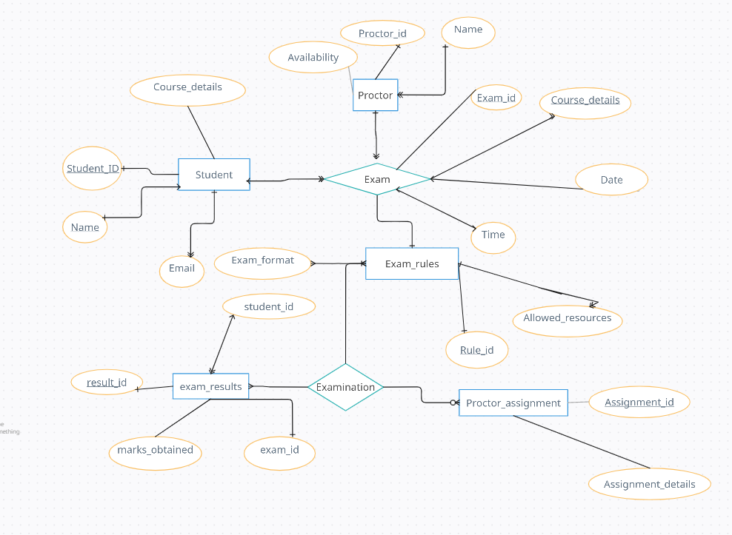

**DDL-OPERATIONS:**

Logical database design-DDL operations (all the tables syntaxes with outputs)

Here is an example of the logical database design for a Proctorial Management System, including DDL operations for creating the necessary tables:

Student Table

CREATE TABLE student (

student_id INT PRIMARY KEY,

name VARCHAR(50) NOT NULL,

email VARCHAR(100) UNIQUE,

course_details VARCHAR(100)

);

Output: Query OK, 0 rows affected

Proctor Table

CREATE TABLE proctor (

proctor_id INT PRIMARY KEY,

name VARCHAR(50) NOT NULL,

contact_details VARCHAR(100),

availability VARCHAR(50)

);

Output: Query OK, 0 rows affected

Exam Table

CREATE TABLE exam (

exam_id INT PRIMARY KEY,

date DATE NOT NULL,

time TIME NOT NULL,

duration INT NOT NULL,

course_details VARCHAR(100)

);

Output: Query OK, 0 rows affected

Exam Rules Table

CREATE TABLE exam_rules (

rule_id INT PRIMARY KEY,

allowed_resources VARCHAR(100),

exam_format VARCHAR(50),

exam_rules VARCHAR(200)

);

Output: Query OK, 0 rows affected

Proctor Assignment Table

CREATE TABLE proctor_assignment (

assignment_id INT PRIMARY KEY,

exam_id INT NOT NULL,

proctor_id INT NOT NULL,

assignment_details VARCHAR(200),

FOREIGN KEY (exam_id) REFERENCES exam(exam_id),

FOREIGN KEY (proctor_id) REFERENCES proctor(proctor_id)

);

Output: Query OK, 0 rows affected

Exam Results Table

CREATE TABLE exam_results (

result_id INT PRIMARY KEY,

exam_id INT NOT NULL,

student_id INT NOT NULL,

marks_obtained FLOAT,

other_details VARCHAR(200),

FOREIGN KEY (exam_id) REFERENCES exam(exam_id),

FOREIGN KEY (student_id) REFERENCES student(student_id)

);

Output: Query OK, 0 rows affected

These DDL operations would create the necessary tables in the Proctorial Management System with the appropriate attributes, primary keys, and foreign keys. The syntax for creating tables may vary depending on the database management system being used. The output for each query confirms that the table was created successfully.

**Enforcing the constraints like primary, foreign key constraints**

To enforce the constraints in the Proctorial Management System, we can use SQL statements to add the necessary primary and foreign key constraints to the tables. Here's an example:

Enforce primary key constraint on the student table:

ALTER TABLE student

ADD CONSTRAINT pk_student PRIMARY KEY (student_id);

Enforce primary key constraint on the proctor table:

ALTER TABLE proctor

ADD CONSTRAINT pk_proctor PRIMARY KEY (proctor_id);

Enforce primary key constraint on the exam table:

ALTER TABLE exam

ADD CONSTRAINT pk_exam PRIMARY KEY (exam_id);

Enforce primary key constraint on the exam_rules table:

ALTER TABLE exam_rules

ADD CONSTRAINT pk_exam_rules PRIMARY KEY (rule_id);

Enforce foreign key constraint on the proctor_assignment table:

ALTER TABLE proctor_assignment

ADD CONSTRAINT fk_exam_proctor

FOREIGN KEY (exam_id) REFERENCES exam(exam_id),

ADD CONSTRAINT fk_proctor_exam

FOREIGN KEY (proctor_id) REFERENCES proctor(proctsssor_id);

s

Enforce foreign key constraint on the exam_results table:

ALTER TABLE exam_results

ADD CONSTRAINT fk_exam_results_exam

FOREIGN KEY (exam_id) REFERENCES exam(exam_id),

ADD CONSTRAINT fk_exam_results_student

FOREIGN KEY (student_id) REFERENCES student(student_id);

These statements will enforce the primary key constraintsThese statements will enforce the primary key constraints on the respective tables and add foreign key constraints to ensure referential integrity between the tables. The exact syntax may vary depending on the database management system being used, but the general structure and logic of the statements should be similar.

Here are some examples of Data Manipulation Language (DML) operations for the Proctorial Management System, along with their outputs:

Insert data into the student table:

INSERT INTO student (student_id, name, email, course_details)

VALUES (1, 'John Doe', 'johndoe@example.com', 'Computer Science');

INSERT INTO student (student_id, name, email, course_details)

VALUES (2, 'Jane Doe', 'janedoe@example.com', 'Mechanical Engineering');

INSERT INTO student (student_id, name, email, course_details)

VALUES (3, 'Bob Smith', 'bobsmith@example.com', 'Electrical Engineering');

Output: Query OK, 3 rows affected

Insert data into the proctor table:

INSERT INTO proctor (proctor_id, name, contact_details, availability)

VALUES (1, 'Alice Brown', 'alicebrown@example.com', 'Monday to Friday, 9am to 5pm');

INSERT INTO proctor (proctor_id, name, contact_details, availability)

VALUES (2, 'Charlie Green', 'charliegreen@example.com', 'Tuesday to Saturday, 10am to 6pm');

Output: Query OK, 2 rows affected

Insert data into the exam table:

INSERT INTO exam (exam_id, date, time, duration, course_details)

VALUES (1, '2023-05-15', '10:00:00', 120, 'Computer Science');

INSERT INTO exam (exam_id, date, time, duration, course_details)

VALUES (2, '2023-05-17', '14:00:00', 180, 'Mechanical Engineering');

Output: Query OK, 2 rows affected

Insert data into the exam_rules table:

INSERT INTO exam_rules (rule_id, allowed_resources, exam_format, exam_rules)

VALUES (1, 'Calculator, ruler', 'Multiple choice', 'No talking allowed');

Output: Query OK, 1 row affected

Update data in the student table:

UPDATE student

SET course_details = 'Information Technology'

WHERE student_id = 3;

Output: Query OK, 1 row affected

These DML operations demonstrate how to add and update data in the various tables of the Proctorial Management System. The output for each query confirms that the operation was successful and indicates how many rows were affected.

Execution ScreenShots:

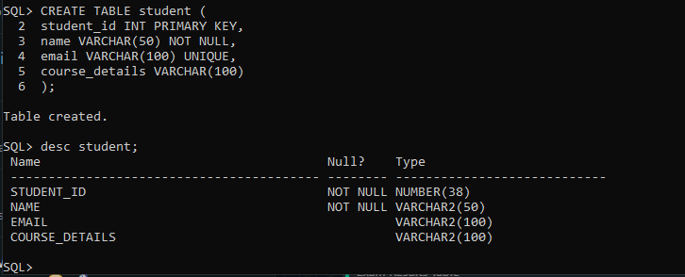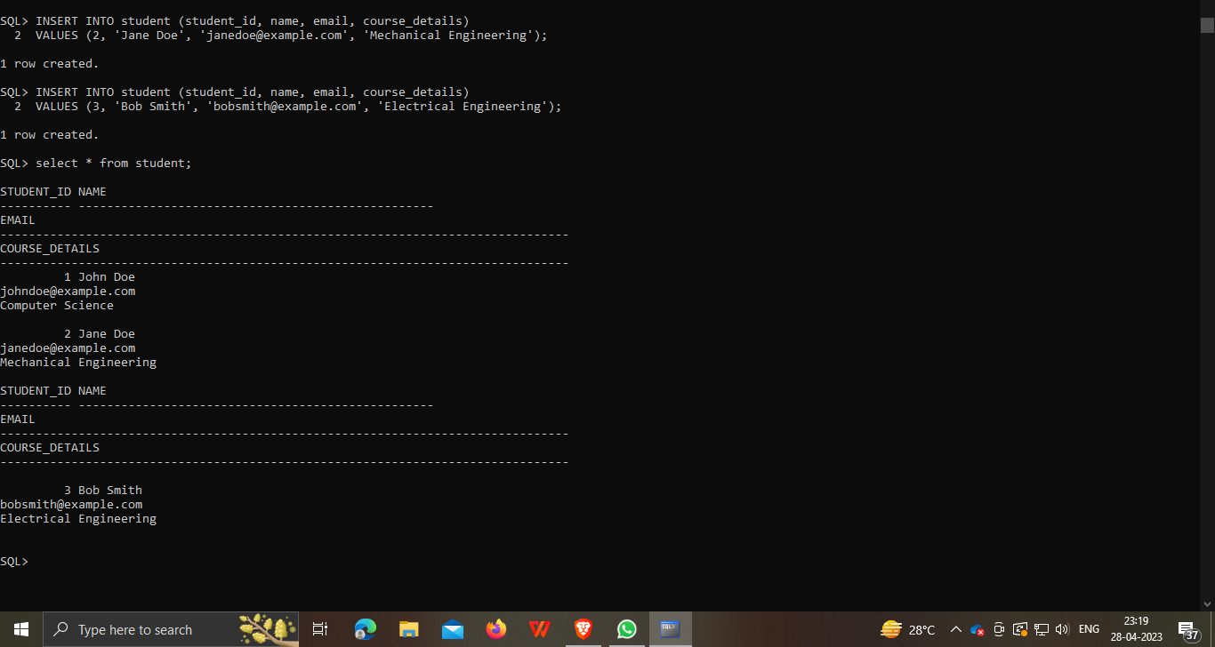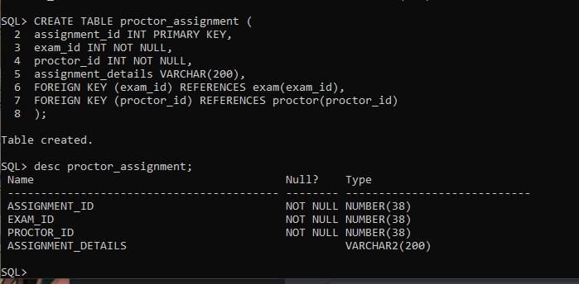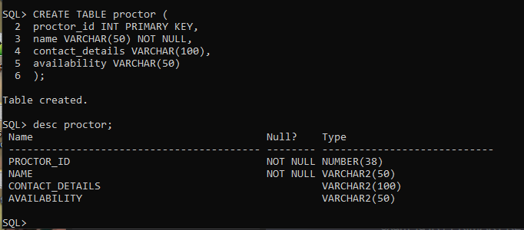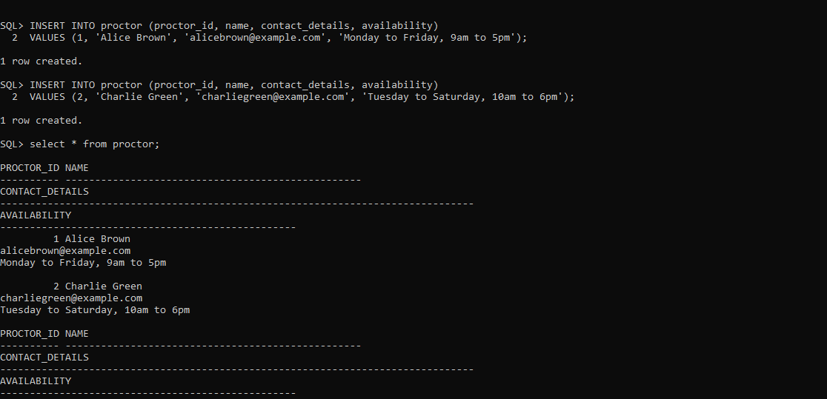

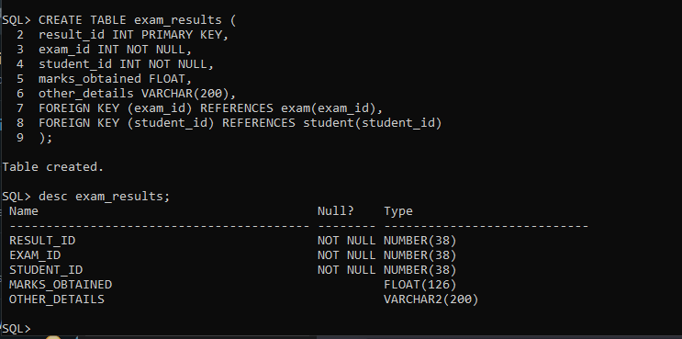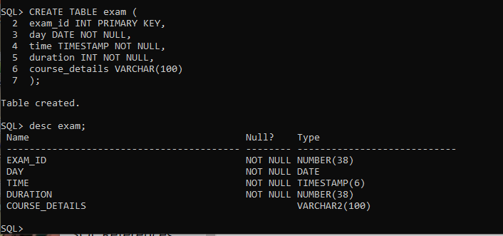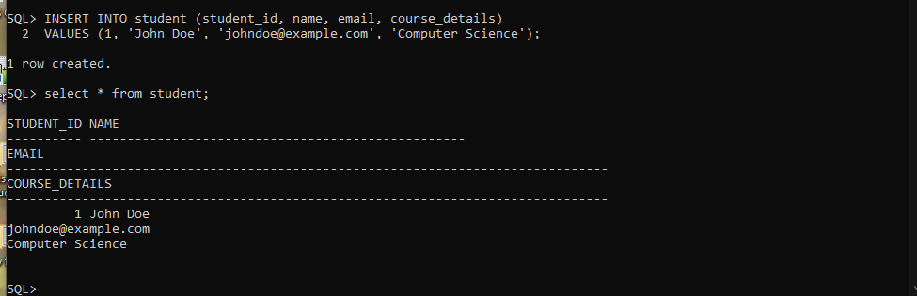

SOURCE CODE:

import javax.swing.*;

import java.awt.*;

import java.awt.event.*;

import java.sql.*;

public class ProctorialManagementSystem extends JFrame {

private static final String JDBC_URL = "jdbc:mysql://localhost:3306/proctorial";

private static final String USERNAME = "root";

private static final String PASSWORD = "laxmansai";

private JMenuBar menuBar;

private JMenu studentMenu, proctorMenu, examMenu, rulesMenu, assignmentMenu, resultsMenu, registerMenu;

private JMenuItem addStudentItem, deleteStudentItem, updateStudentItem, displayStudentItem , displayExamRegistrationItem;

private JMenuItem addProctorItem, deleteProctorItem, updateProctorItem, displayProctorItem;

private JMenuItem addExamItem, deleteExamItem, updateExamItem, displayExamItem;

private JMenuItem addRulesItem, deleteRulesItem, updateRulesItem, displayRulesItem;

private JMenuItem addAssignmentItem, deleteAssignmentItem, updateAssignmentItem, displayAssignmentItem;

private JMenuItem addResultsItem, deleteResultsItem, updateResultsItem, displayResultsItem;

public ProctorialManagementSystem() {

setTitle("Proctorial Management System");

setSize(800, 600);

setDefaultCloseOperation(JFrame.EXIT_ON_CLOSE);

setLocationRelativeTo(null);

// Create the menu bar

menuBar = new JMenuBar();

// Create the menus

studentMenu = new JMenu("Student");

proctorMenu = new JMenu("Proctor");

examMenu = new JMenu("Exam");

rulesMenu = new JMenu("Exam Rules");

assignmentMenu = new JMenu("Proctor Assignment");

resultsMenu = new JMenu("Exam Results");

registerMenu = new JMenu("Exam Registration");

// Create the menu items

addStudentItem = new JMenuItem("Add Student");

deleteStudentItem = new JMenuItem("Delete Student");

updateStudentItem = new JMenuItem("Update Student");

displayStudentItem = new JMenuItem("Display Students");

addProctorItem = new JMenuItem("Add Proctor");

deleteProctorItem = new JMenuItem("Delete Proctor");

updateProctorItem = new JMenuItem("Update Proctor");

displayProctorItem = new JMenuItem("Display Proctors");

addExamItem = new JMenuItem("Add Exam");

deleteExamItem = new JMenuItem("Delete Exam");

updateExamItem = new JMenuItem("Update Exam");

displayExamItem = new JMenuItem("Display Exams");

addRulesItem = new JMenuItem("Add Exam Rules");

deleteRulesItem = new JMenuItem("Delete Exam Rules");

updateRulesItem = new JMenuItem("Update Exam Rules");

displayRulesItem = new JMenuItem("Display Exam Rules");

addAssignmentItem = new JMenuItem("Add Proctor Assignment");

deleteAssignmentItem = new JMenuItem("Delete Proctor Assignment");

updateAssignmentItem = new JMenuItem("Update Proctor Assignment");

displayAssignmentItem = new JMenuItem("Display Proctor Assignments");

addResultsItem = new JMenuItem("Add Exam Results");

deleteResultsItem = new JMenuItem("Delete Exam Results");

updateResultsItem = new JMenuItem("Update Exam Results");

displayResultsItem = new JMenuItem("Display Exam Results");

displayExamRegistrationItem = new JMenuItem("Display Exam Registration");

// Add action listeners to menu items

displayExamRegistrationItem.addActionListener(new ActionListener() {

public void actionPerformed(ActionEvent e) {

displayExamRegistration();

}

});

addStudentItem.addActionListener(new ActionListener() {

public void actionPerformed(ActionEvent e) {

addStudent();

}

});

deleteStudentItem.addActionListener(new ActionListener() {

public void actionPerformed(ActionEvent e) {

deleteStudent();

}

});

updateStudentItem.addActionListener(new ActionListener() {

public void actionPerformed(ActionEvent e) {

updateStudent();

}

});

displayStudentItem.addActionListener(new ActionListener() {

public void actionPerformed(ActionEvent e) {

displayStudents();

}

});

addProctorItem.addActionListener(new ActionListener() {

public void actionPerformed(ActionEvent e) {

addProctor();

}

});

deleteProctorItem.addActionListener(new ActionListener() {

public void actionPerformed(ActionEvent e) {

deleteProctor();

}

});

updateProctorItem.addActionListener(new ActionListener() {

public void actionPerformed(ActionEvent e) {

updateProctor();

}

});

displayProctorItem.addActionListener(new ActionListener() {

public void actionPerformed(ActionEvent e) {

displayProctors();

}

});

addExamItem.addActionListener(new ActionListener() {

public void actionPerformed(ActionEvent e) {

addExam();

}

});

deleteExamItem.addActionListener(new ActionListener() {

public void actionPerformed(ActionEvent e) {

deleteExam();

}

});

updateExamItem.addActionListener(new ActionListener() {

public void actionPerformed(ActionEvent e) {

updateExam();

}

});

displayExamItem.addActionListener(new ActionListener() {

public void actionPerformed(ActionEvent e) {

displayExams();

}

});

addRulesItem.addActionListener(new ActionListener() {

public void actionPerformed(ActionEvent e) {

addExamRules();

}

});

deleteRulesItem.addActionListener(new ActionListener() {

public void actionPerformed(ActionEvent e) {

deleteExamRules();

}

});

updateRulesItem.addActionListener(new ActionListener() {

public void actionPerformed(ActionEvent e) {

updateExamRules();

}

});

displayRulesItem.addActionListener(new ActionListener() {

public void actionPerformed(ActionEvent e) {

displayExamRules();

}

});

addAssignmentItem.addActionListener(new ActionListener() {

public void actionPerformed(ActionEvent e) {

addProctorAssignment();

}

});

deleteAssignmentItem.addActionListener(new ActionListener() {

public void actionPerformed(ActionEvent e) {

deleteProctorAssignment();

}

});

updateAssignmentItem.addActionListener(new ActionListener() {

public void actionPerformed(ActionEvent e) {

updateProctorAssignment();

}

});

displayAssignmentItem.addActionListener(new ActionListener() {

public void actionPerformed(ActionEvent e) {

displayProctorAssignments();

}

});

addResultsItem.addActionListener(new ActionListener() {

public void actionPerformed(ActionEvent e) {

addExamResults();

}

});

deleteResultsItem.addActionListener(new ActionListener() {

public void actionPerformed(ActionEvent e) {

deleteExamResults();

}

});

updateResultsItem.addActionListener(new ActionListener() {

public void actionPerformed(ActionEvent e) {

updateExamResults();

}

});

displayResultsItem.addActionListener(new ActionListener() {

public void actionPerformed(ActionEvent e) {

displayExamResults();

}

});

// Add menu items to menus

registerMenu.add(displayExamRegistrationItem);

studentMenu.add(addStudentItem);

studentMenu.add(deleteStudentItem);

studentMenu.add(updateStudentItem);

studentMenu.add(displayStudentItem);

proctorMenu.add(addProctorItem);

proctorMenu.add(deleteProctorItem);

proctorMenu.add(updateProctorItem);

proctorMenu.add(displayProctorItem);

examMenu.add(addExamItem);

examMenu.add(deleteExamItem);

examMenu.add(updateExamItem);

examMenu.add(displayExamItem);

rulesMenu.add(addRulesItem);

rulesMenu.add(deleteRulesItem);

rulesMenu.add(updateRulesItem);

rulesMenu.add(displayRulesItem);

assignmentMenu.add(addAssignmentItem);

assignmentMenu.add(deleteAssignmentItem);

assignmentMenu.add(updateAssignmentItem);

assignmentMenu.add(displayAssignmentItem);

resultsMenu.add(addResultsItem);

resultsMenu.add(deleteResultsItem);

resultsMenu.add(updateResultsItem);

resultsMenu.add(displayResultsItem);

// Add menus to menu bar

menuBar.add(studentMenu);

menuBar.add(proctorMenu);

menuBar.add(examMenu);

menuBar.add(rulesMenu);

menuBar.add(assignmentMenu);

menuBar.add(resultsMenu);

menuBar.add(registerMenu);

// Set the menu bar

setJMenuBar(menuBar);

}

private void addStudent() {

JTextField idField = new JTextField(10);

JTextField nameField = new JTextField(10);

JTextField emailField = new JTextField(10);

JTextField courseField = new JTextField(10);

JPanel panel = new JPanel(new GridBagLayout());

GridBagConstraints constraints = new GridBagConstraints();

constraints.fill = GridBagConstraints.HORIZONTAL;

constraints.gridx = 0;

constraints.gridy = 0;

panel.add(new JLabel("Student ID:"), constraints);

constraints.gridx = 1;

panel.add(idField, constraints);

constraints.gridx = 0;

constraints.gridy = 1;

panel.add(new JLabel("Name:"), constraints);

constraints.gridx = 1;

panel.add(nameField, constraints);

constraints.gridx = 0;

constraints.gridy = 2;

panel.add(new JLabel("Email:"), constraints);

constraints.gridx = 1;

panel.add(emailField, constraints);

constraints.gridx = 0;

constraints.gridy = 3;

panel.add(new JLabel("Course Details:"), constraints);

constraints.gridx = 1;

panel.add(courseField, constraints);

int result = JOptionPane.showConfirmDialog(null, panel, "Add Student", JOptionPane.OK_CANCEL_OPTION);

if (result == JOptionPane.OK_OPTION) {

int studentId = Integer.parseInt(idField.getText());

String name = nameField.getText();

String email = emailField.getText();

String courseDetails = courseField.getText();

// Insert the student record into the database using JDBC

try (Connection connection = DriverManager.getConnection(JDBC_URL, USERNAME, PASSWORD);

PreparedStatement statement = connection.prepareStatement(

"INSERT INTO student (student_id, name, email, course_details) VALUES (?, ?, ?, ?)")) {

statement.setInt(1, studentId);

statement.setString(2, name);

statement.setString(3, email);

statement.setString(4, courseDetails);

int rowsAffected = statement.executeUpdate();

if (rowsAffected > 0) {

JOptionPane.showMessageDialog(null, "Student added successfully!");

} else {

JOptionPane.showMessageDialog(null, "Failed to add student.", "Error", JOptionPane.ERROR_MESSAGE);

}

} catch (SQLException e) {

JOptionPane.showMessageDialog(null, "Error adding student: " + e.getMessage(), "Error", JOptionPane.ERROR_MESSAGE);

}

}

}

private void deleteStudent() {

JTextField idField = new JTextField(10);

JPanel panel = new JPanel();

panel.add(new JLabel("Student ID:"));

panel.add(idField);

int result = JOptionPane.showConfirmDialog(null, panel, "Delete Student", JOptionPane.OK_CANCEL_OPTION);

if (result == JOptionPane.OK_OPTION) {

int studentId = Integer.parseInt(idField.getText());

// Delete the student record from the database using JDBC

try (Connection connection = DriverManager.getConnection(JDBC_URL, USERNAME, PASSWORD);

PreparedStatement statement = connection.prepareStatement("DELETE FROM student WHERE student_id = ?")) {

statement.setInt(1, studentId);

int rowsAffected = statement.executeUpdate();

if (rowsAffected > 0) {

JOptionPane.showMessageDialog(null, "Student deleted successfully!");

} else {

JOptionPane.showMessageDialog(null, "No student found with the given ID.", "Error", JOptionPane.ERROR_MESSAGE);

}

} catch (SQLException e) {

JOptionPane.showMessageDialog(null, "Error deleting student: " + e.getMessage(), "Error", JOptionPane.ERROR_MESSAGE);

}

}

}

private void updateStudent() {

JTextField idField = new JTextField(10);

JTextField nameField = new JTextField(50);

JTextField emailField = new JTextField(100);

JTextField courseField = new JTextField(100);

JPanel panel = new JPanel(new GridLayout(5, 2));

panel.add(new JLabel("Student ID:"));

panel.add(idField);

panel.add(new JLabel("Name:"));

panel.add(nameField);

panel.add(new JLabel("Email:"));

panel.add(emailField);

panel.add(new JLabel("Course Details:"));

panel.add(courseField);

int result = JOptionPane.showConfirmDialog(null, panel, "Update Student", JOptionPane.OK_CANCEL_OPTION);

if (result == JOptionPane.OK_OPTION) {

int studentId = Integer.parseInt(idField.getText());

String name = nameField.getText();

String email = emailField.getText();

String courseDetails = courseField.getText();

// Update the student record in the database using JDBC

try (Connection connection = DriverManager.getConnection(JDBC_URL, USERNAME, PASSWORD);

PreparedStatement statement = connection.prepareStatement(

"UPDATE student SET name = ?, email = ?, course_details = ? WHERE student_id = ?")) {

statement.setString(1, name);

statement.setString(2, email);

statement.setString(3, courseDetails);

statement.setInt(4, studentId);

int rowsAffected = statement.executeUpdate();

if (rowsAffected > 0) {

JOptionPane.showMessageDialog(null, "Student updated successfully!");

} else {

JOptionPane.showMessageDialog(null, "No student found with the given ID.", "Error", JOptionPane.ERROR_MESSAGE);

}

} catch (SQLException e) {

JOptionPane.showMessageDialog(null, "Error updating student: " + e.getMessage(), "Error", JOptionPane.ERROR_MESSAGE);

}

}

}

private void displayStudents() {

// Retrieve and display the list of students from the database using JDBC

try (Connection connection = DriverManager.getConnection(JDBC_URL, USERNAME, PASSWORD);

Statement statement = connection.createStatement();

ResultSet resultSet = statement.executeQuery("SELECT * FROM student")) {

StringBuilder sb = new StringBuilder();

sb.append("Student ID\tName\tEmail\t\tCourse Details\n");

while (resultSet.next()) {

int studentId = resultSet.getInt("student_id");

String name = resultSet.getString("name");

String email = resultSet.getString("email");

String courseDetails = resultSet.getString("course_details");

sb.append(studentId).append("\t").append(name).append("\t").append(email).append("\t").append(courseDetails).append("\n");

}

JTextArea textArea = new JTextArea(sb.toString());

JScrollPane scrollPane = new JScrollPane(textArea);

scrollPane.setPreferredSize(new Dimension(400, 300));

JOptionPane.showMessageDialog(null, scrollPane, "Student List", JOptionPane.PLAIN_MESSAGE);

} catch (SQLException e) {

JOptionPane.showMessageDialog(null, "Error retrieving student list: " + e.getMessage(), "Error", JOptionPane.ERROR_MESSAGE);

}

}

//Proctor

private void addProctor() {

JTextField idField = new JTextField(10);

JTextField nameField = new JTextField(50);

JTextField contactField = new JTextField(50);

JTextField availabilityField = new JTextField(50);

JPanel panel = new JPanel(new GridBagLayout());

GridBagConstraints constraints = new GridBagConstraints();

constraints.fill = GridBagConstraints.HORIZONTAL;

constraints.gridx = 0;

constraints.gridy = 0;

panel.add(new JLabel("Proctor ID:"), constraints);

constraints.gridx = 1;

panel.add(idField, constraints);

constraints.gridx = 0;

constraints.gridy = 1;

panel.add(new JLabel("Name:"), constraints);

constraints.gridx = 1;

panel.add(nameField, constraints);

constraints.gridx = 0;

constraints.gridy = 2;

panel.add(new JLabel("Contact Details:"), constraints);

constraints.gridx = 1;

panel.add(contactField, constraints);

constraints.gridx = 0;

constraints.gridy = 3;

panel.add(new JLabel("Availability:"), constraints);

constraints.gridx = 1;

panel.add(availabilityField, constraints);

int result = JOptionPane.showConfirmDialog(null, panel, "Add Proctor", JOptionPane.OK_CANCEL_OPTION);

if (result == JOptionPane.OK_OPTION) {

int proctorId = Integer.parseInt(idField.getText());

String name = nameField.getText();

String contactDetails = contactField.getText();

String availability = availabilityField.getText();

// Insert the proctor record into the database using JDBC

try (Connection connection = DriverManager.getConnection(JDBC_URL, USERNAME, PASSWORD);

PreparedStatement statement = connection.prepareStatement(

"INSERT INTO proctor (proctor_id, name, contact_details, availability) VALUES (?, ?, ?, ?)")) {

statement.setInt(1, proctorId);

statement.setString(2, name);

statement.setString(3, contactDetails);

statement.setString(4, availability);

int rowsAffected = statement.executeUpdate();

if (rowsAffected > 0) {

JOptionPane.showMessageDialog(null, "Proctor added successfully!");

}

} catch (SQLException e) {

JOptionPane.showMessageDialog(null, "Error adding proctor: " + e.getMessage(), "Error", JOptionPane.ERROR_MESSAGE);

}

}

}

private void deleteProctor() {

JTextField idField = new JTextField(10);

JPanel panel = new JPanel(new GridLayout(1, 2));

panel.add(new JLabel("Proctor ID:"));

panel.add(idField);

int result = JOptionPane.showConfirmDialog(null, panel, "Delete Proctor", JOptionPane.OK_CANCEL_OPTION);

if (result == JOptionPane.OK_OPTION) {

int proctorId = Integer.parseInt(idField.getText());

// Delete the proctor record from the database using JDBC

try (Connection connection = DriverManager.getConnection(JDBC_URL, USERNAME, PASSWORD);

PreparedStatement statement = connection.prepareStatement(

"DELETE FROM proctor WHERE proctor_id = ?")) {

statement.setInt(1, proctorId);

int rowsAffected = statement.executeUpdate();

if (rowsAffected > 0) {

JOptionPane.showMessageDialog(null, "Proctor deleted successfully!");

} else {

JOptionPane.showMessageDialog(null, "No proctor found with the given ID.", "Error", JOptionPane.ERROR_MESSAGE);

}

} catch (SQLException e) {

JOptionPane.showMessageDialog(null, "Error deleting proctor: " + e.getMessage(), "Error", JOptionPane.ERROR_MESSAGE);

}

}

}

private void updateProctor() {

JTextField idField = new JTextField(10);

JTextField nameField = new JTextField(50);

JTextField contactField = new JTextField(50);

JTextField availabilityField = new JTextField(50);

JPanel panel = new JPanel(new GridBagLayout());

GridBagConstraints constraints = new GridBagConstraints();

constraints.fill = GridBagConstraints.HORIZONTAL;

// Proctor ID label

constraints.gridx = 0;

constraints.gridy = 0;

panel.add(new JLabel("Proctor ID:"), constraints);

// Proctor ID field

constraints.gridx = 1;

panel.add(idField, constraints);

// Name label

constraints.gridx = 0;

constraints.gridy = 1;

panel.add(new JLabel("Name:"), constraints);

// Name field

constraints.gridx = 1;

panel.add(nameField, constraints);

// Contact Details label

constraints.gridx = 0;

constraints.gridy = 2;

panel.add(new JLabel("Contact Details:"), constraints);

// Contact Details field

constraints.gridx = 1;

panel.add(contactField, constraints);

// Availability label

constraints.gridx = 0;

constraints.gridy = 3;

panel.add(new JLabel("Availability:"), constraints);

// Availability field

constraints.gridx = 1;

panel.add(availabilityField, constraints);

int result = JOptionPane.showConfirmDialog(null, panel, "Update Proctor", JOptionPane.OK_CANCEL_OPTION);

if (result == JOptionPane.OK_OPTION) {

int proctorId = Integer.parseInt(idField.getText());

String name = nameField.getText();

String contactDetails = contactField.getText();

String availability = availabilityField.getText();

// Update the proctor record in the database using JDBC

try (Connection connection = DriverManager.getConnection(JDBC_URL, USERNAME, PASSWORD);

PreparedStatement statement = connection.prepareStatement(

"UPDATE proctor SET name = ?, contact_details = ?, availability = ? WHERE proctor_id = ?")) {

statement.setString(1, name);

statement.setString(2, contactDetails);

statement.setString(3, availability);

statement.setInt(4, proctorId);

int rowsAffected = statement.executeUpdate();

if (rowsAffected > 0) {

JOptionPane.showMessageDialog(null, "Proctor updated successfully!");

} else {

JOptionPane.showMessageDialog(null, "No proctor found with the given ID.", "Error", JOptionPane.ERROR_MESSAGE);

}

} catch (SQLException e) {

JOptionPane.showMessageDialog(null, "Error updating proctor: " + e.getMessage(), "Error", JOptionPane.ERROR_MESSAGE);

}

}

}

private void displayProctors() {

// Retrieve and display the list of proctors from the database using JDBC

try (Connection connection = DriverManager.getConnection(JDBC_URL, USERNAME, PASSWORD);

Statement statement = connection.createStatement();

ResultSet resultSet = statement.executeQuery("SELECT * FROM proctor")) {

StringBuilder sb = new StringBuilder();

sb.append("Proctor ID\tName\tcontact_details\tavailability\n");

while (resultSet.next()) {

int proctorId = resultSet.getInt("proctor_id");

String name = resultSet.getString("name");

String course_details = resultSet.getString("contact_details");

String availability = resultSet.getString("availability");

sb.append(proctorId).append("\t").append(name).append("\t").append(course_details).append("\t").append(availability).append("\n");

}

JTextArea textArea = new JTextArea(sb.toString());

JScrollPane scrollPane = new JScrollPane(textArea);

scrollPane.setPreferredSize(new Dimension(400, 300));

JOptionPane.showMessageDialog(null, scrollPane, "Proctor List", JOptionPane.PLAIN_MESSAGE);

} catch (SQLException e) {

JOptionPane.showMessageDialog(null, "Error retrieving proctor list: " + e.getMessage(), "Error", JOptionPane.ERROR_MESSAGE);

}

}

//Exam

private void addExam() {

JTextField idField = new JTextField(10);

JTextField dateField = new JTextField(10);

JTextField timeField = new JTextField(10);

JTextField durationField = new JTextField(10);

JTextField courseField = new JTextField(50);

JPanel panel = new JPanel(new GridBagLayout());

GridBagConstraints constraints = new GridBagConstraints();

constraints.fill = GridBagConstraints.HORIZONTAL;

// Exam ID label

constraints.gridx = 0;

constraints.gridy = 0;

panel.add(new JLabel("Exam ID:"), constraints);

// Exam ID field

constraints.gridx = 1;

panel.add(idField, constraints);

// Date label

constraints.gridx = 0;

constraints.gridy = 1;

panel.add(new JLabel("Date (YYYY-MM-DD):"), constraints);

// Date field

constraints.gridx = 1;

panel.add(dateField, constraints);

// Time label

constraints.gridx = 0;

constraints.gridy = 2;

panel.add(new JLabel("Time (HH:MM:SS):"), constraints);

// Time field

constraints.gridx = 1;

panel.add(timeField, constraints);

// Duration label

constraints.gridx = 0;

constraints.gridy = 3;

panel.add(new JLabel("Duration (in minutes):"), constraints);

// Duration field

constraints.gridx = 1;

panel.add(durationField, constraints);

// Course Details label

constraints.gridx = 0;

constraints.gridy = 4;

panel.add(new JLabel("Course Details:"), constraints);

// Course Details field

constraints.gridx = 1;

panel.add(courseField, constraints);

int result = JOptionPane.showConfirmDialog(null, panel, "Add Exam", JOptionPane.OK_CANCEL_OPTION);

if (result == JOptionPane.OK_OPTION) {

int examId = Integer.parseInt(idField.getText());

String date = dateField.getText();

String time = timeField.getText();

int duration = Integer.parseInt(durationField.getText());

String courseDetails = courseField.getText();

// Insert the exam record into the database using JDBC

try (Connection connection = DriverManager.getConnection(JDBC_URL, USERNAME, PASSWORD);

PreparedStatement statement = connection.prepareStatement(

"INSERT INTO exam (exam_id, date, time, duration, course_details) VALUES (?, ?, ?, ?, ?)")) {

statement.setInt(1, examId);

statement.setString(2, date);

statement.setString(3, time);

statement.setInt(4, duration);

statement.setString(5, courseDetails);

int rowsAffected = statement.executeUpdate();

if (rowsAffected > 0) {

JOptionPane.showMessageDialog(null, "Exam added successfully!");

}

} catch (SQLException e) {

JOptionPane.showMessageDialog(null, "Error adding exam: " + e.getMessage(), "Error", JOptionPane.ERROR_MESSAGE);

}

}

}

private void deleteExam() {

JTextField idField = new JTextField(10);

JPanel panel = new JPanel(new GridLayout(1, 2));

panel.add(new JLabel("Exam ID:"));

panel.add(idField);

int result = JOptionPane.showConfirmDialog(null, panel, "Delete Exam", JOptionPane.OK_CANCEL_OPTION);

if (result == JOptionPane.OK_OPTION) {

int examId = Integer.parseInt(idField.getText());

// Delete the exam record from the database using JDBC

try (Connection connection = DriverManager.getConnection(JDBC_URL, USERNAME, PASSWORD);

PreparedStatement statement = connection.prepareStatement(

"DELETE FROM exam WHERE exam_id = ?")) {

statement.setInt(1, examId);

int rowsAffected = statement.executeUpdate();

if (rowsAffected > 0) {

JOptionPane.showMessageDialog(null, "Exam deleted successfully!");

} else {

JOptionPane.showMessageDialog(null, "No exam found with the given ID.", "Error", JOptionPane.ERROR_MESSAGE);

}

} catch (SQLException e) {

JOptionPane.showMessageDialog(null, "Error deleting exam: " + e.getMessage(), "Error", JOptionPane.ERROR_MESSAGE);

}

}

}

private void updateExam() {

JTextField idField = new JTextField(10);

JTextField dateField = new JTextField(10);

JTextField timeField = new JTextField(10);

JTextField durationField = new JTextField(10);

JTextField courseField = new JTextField(50);

JPanel panel = new JPanel(new GridBagLayout());

GridBagConstraints constraints = new GridBagConstraints();

constraints.fill = GridBagConstraints.HORIZONTAL;

// Exam ID label

constraints.gridx = 0;

constraints.gridy = 0;

panel.add(new JLabel("Exam ID:"), constraints);

// Exam ID field

constraints.gridx = 1;

panel.add(idField, constraints);

// Date label

constraints.gridx = 0;

constraints.gridy = 1;

panel.add(new JLabel("Date (YYYY-MM-DD):"), constraints);

// Date field

constraints.gridx = 1;

panel.add(dateField, constraints);

// Time label

constraints.gridx = 0;

constraints.gridy = 2;

panel.add(new JLabel("Time (HH:MM:SS):"), constraints);

// Time field

constraints.gridx = 1;

panel.add(timeField, constraints);

// Duration label

constraints.gridx = 0;

constraints.gridy = 3;

panel.add(new JLabel("Duration (in minutes):"), constraints);

// Duration field

constraints.gridx = 1;

panel.add(durationField, constraints);

// Course Details label

constraints.gridx = 0;

constraints.gridy = 4;

panel.add(new JLabel("Course Details:"), constraints);

// Course Details field

constraints.gridx = 1;

panel.add(courseField, constraints);

int result = JOptionPane.showConfirmDialog(null, panel, "Update Exam", JOptionPane.OK_CANCEL_OPTION);

if (result == JOptionPane.OK_OPTION) {

int examId = Integer.parseInt(idField.getText());

String date = dateField.getText();

String time = timeField.getText();

int duration = Integer.parseInt(durationField.getText());

String courseDetails = courseField.getText();

// Update the exam record in the database using JDBC

try (Connection connection = DriverManager.getConnection(JDBC_URL, USERNAME, PASSWORD);

PreparedStatement statement = connection.prepareStatement(

"UPDATE exam SET date = ?, time = ?, duration = ?, course_details = ? WHERE exam_id = ?")) {

statement.setString(1, date);

statement.setString(2, time);

statement.setInt(3, duration);

statement.setString(4, courseDetails);

statement.setInt(5, examId);

int rowsAffected = statement.executeUpdate();

if (rowsAffected > 0) {

JOptionPane.showMessageDialog(null, "Exam updated successfully!");

} else {

JOptionPane.showMessageDialog(null, "No exam found with the given ID.", "Error", JOptionPane.ERROR_MESSAGE);

}

} catch (SQLException e) {

JOptionPane.showMessageDialog(null, "Error updating exam: " + e.getMessage(), "Error", JOptionPane.ERROR_MESSAGE);

}

}

}

private void displayExams() {

// Fetch and display the exam records from the database using JDBC

try (Connection connection = DriverManager.getConnection(JDBC_URL, USERNAME, PASSWORD);

Statement statement = connection.createStatement();

ResultSet resultSet = statement.executeQuery("SELECT * FROM exam")) {

StringBuilder sb = new StringBuilder();

while (resultSet.next()) {

int examId = resultSet.getInt("exam_id");

String date = resultSet.getString("date");

String time = resultSet.getString("time");

int duration = resultSet.getInt("duration");

String courseDetails = resultSet.getString("course_details");

sb.append("Exam ID: ").append(examId).append("\n");

sb.append("Date: ").append(date).append("\n");

sb.append("Time: ").append(time).append("\n");

sb.append("Duration: ").append(duration).append(" minutes\n");

sb.append("Course Details: ").append(courseDetails).append("\n");

sb.append("-------------------------\n");

}

JTextArea textArea = new JTextArea(sb.toString());

JScrollPane scrollPane = new JScrollPane(textArea);

scrollPane.setPreferredSize(new Dimension(400, 300));

JOptionPane.showMessageDialog(null, scrollPane, "Exam List", JOptionPane.PLAIN_MESSAGE);

} catch (SQLException e) {

JOptionPane.showMessageDialog(null, "Error fetching exams: " + e.getMessage(), "Error", JOptionPane.ERROR_MESSAGE);

}

}

private void addExamRules() {

JTextField idField = new JTextField(10);

JTextField allowedResourcesField = new JTextField(100);

JTextField examFormatField = new JTextField(50);

JTextField examRulesField = new JTextField(100);

JPanel panel = new JPanel(new GridBagLayout());

GridBagConstraints constraints = new GridBagConstraints();

constraints.fill = GridBagConstraints.HORIZONTAL;

// Rule ID label

constraints.gridx = 0;

constraints.gridy = 0;

panel.add(new JLabel("Rule ID:"), constraints);

// Rule ID field

constraints.gridx = 1;

panel.add(idField, constraints);

// Allowed Resources label

constraints.gridx = 0;

constraints.gridy = 1;

panel.add(new JLabel("Allowed Resources:"), constraints);

// Allowed Resources field

constraints.gridx = 1;

panel.add(allowedResourcesField, constraints);

// Exam Format label

constraints.gridx = 0;

constraints.gridy = 2;

panel.add(new JLabel("Exam Format:"), constraints);

// Exam Format field

constraints.gridx = 1;

panel.add(examFormatField, constraints);

// Exam Rules label

constraints.gridx = 0;

constraints.gridy = 3;

panel.add(new JLabel("Exam Rules:"), constraints);

// Exam Rules field

constraints.gridx = 1;

panel.add(examRulesField, constraints);

int result = JOptionPane.showConfirmDialog(null, panel, "Add Exam Rules", JOptionPane.OK_CANCEL_OPTION);

if (result == JOptionPane.OK_OPTION) {

int ruleId = Integer.parseInt(idField.getText());

String allowedResources = allowedResourcesField.getText();

String examFormat = examFormatField.getText();

String examRules = examRulesField.getText();

// Insert the exam rules record into the database using JDBC

try (Connection connection = DriverManager.getConnection(JDBC_URL, USERNAME, PASSWORD);

PreparedStatement statement = connection.prepareStatement(

"INSERT INTO exam_rules (rule_id, allowed_resources, exam_format, exam_rules) VALUES (?, ?, ?, ?)")) {

statement.setInt(1, ruleId);

statement.setString(2, allowedResources);

statement.setString(3, examFormat);

statement.setString(4, examRules);

int rowsAffected = statement.executeUpdate();

if (rowsAffected > 0) {

JOptionPane.showMessageDialog(null, "Exam rules added successfully!");

}

} catch (SQLException e) {

JOptionPane.showMessageDialog(null, "Error adding exam rules: " + e.getMessage(), "Error", JOptionPane.ERROR_MESSAGE);

}

}

}

private void deleteExamRules() {

JTextField idField = new JTextField(10);

JPanel panel = new JPanel(new GridLayout(1, 2));

panel.add(new JLabel("Rule ID:"));

panel.add(idField);

int result = JOptionPane.showConfirmDialog(null, panel, "Delete Exam Rules", JOptionPane.OK_CANCEL_OPTION);

if (result == JOptionPane.OK_OPTION) {

int ruleId = Integer.parseInt(idField.getText());

// Delete the exam rules record from the database using JDBC

try (Connection connection = DriverManager.getConnection(JDBC_URL, USERNAME, PASSWORD);

PreparedStatement statement = connection.prepareStatement(

"DELETE FROM exam_rules WHERE rule_id = ?")) {

statement.setInt(1, ruleId);

int rowsAffected = statement.executeUpdate();

if (rowsAffected > 0) {

JOptionPane.showMessageDialog(null, "Exam rules deleted successfully!");

} else {

JOptionPane.showMessageDialog(null, "No exam rules found with the given ID.", "Error", JOptionPane.ERROR_MESSAGE);

}

} catch (SQLException e) {

JOptionPane.showMessageDialog(null, "Error deleting exam rules: " + e.getMessage(), "Error", JOptionPane.ERROR_MESSAGE);

}

}

}

private void updateExamRules() {

JTextField idField = new JTextField(10);

JTextField allowedResourcesField = new JTextField(100);

JTextField examFormatField = new JTextField(50);

JTextField examRulesField = new JTextField(100);

JPanel panel = new JPanel(new GridBagLayout());

GridBagConstraints constraints = new GridBagConstraints();

constraints.fill = GridBagConstraints.HORIZONTAL;

// Rule ID label

constraints.gridx = 0;

constraints.gridy = 0;

panel.add(new JLabel("Rule ID:"), constraints);

// Rule ID field

constraints.gridx = 1;

panel.add(idField, constraints);

// Allowed Resources label

constraints.gridx = 0;

constraints.gridy = 1;

panel.add(new JLabel("Allowed Resources:"), constraints);

// Allowed Resources field

constraints.gridx = 1;

panel.add(allowedResourcesField, constraints);

// Exam Format label

constraints.gridx = 0;

constraints.gridy = 2;

panel.add(new JLabel("Exam Format:"), constraints);

// Exam Format field

constraints.gridx = 1;

panel.add(examFormatField, constraints);

// Exam Rules label

constraints.gridx = 0;

constraints.gridy = 3;

panel.add(new JLabel("Exam Rules:"), constraints);

// Exam Rules field

constraints.gridx = 1;

panel.add(examRulesField, constraints);

int result = JOptionPane.showConfirmDialog(null, panel, "Update Exam Rules", JOptionPane.OK_CANCEL_OPTION);

if (result == JOptionPane.OK_OPTION) {

int ruleId = Integer.parseInt(idField.getText());

String allowedResources = allowedResourcesField.getText();

String examFormat = examFormatField.getText();

String examRules = examRulesField.getText();

// Update the exam rules record in the database using JDBC

try (Connection connection = DriverManager.getConnection(JDBC_URL, USERNAME, PASSWORD);

PreparedStatement statement = connection.prepareStatement(

"UPDATE exam_rules SET allowed_resources = ?, exam_format = ?, exam_rules = ? WHERE rule_id = ?")) {

statement.setString(1, allowedResources);

statement.setString(2, examFormat);

statement.setString(3, examRules);

statement.setInt(4, ruleId);

int rowsAffected = statement.executeUpdate();

if (rowsAffected > 0) {

JOptionPane.showMessageDialog(null, "Exam rules updated successfully!");

} else {

JOptionPane.showMessageDialog(null, "No exam rules found with the given ID.", "Error", JOptionPane.ERROR_MESSAGE);

}

} catch (SQLException e) {

JOptionPane.showMessageDialog(null, "Error updating exam rules: " + e.getMessage(), "Error", JOptionPane.ERROR_MESSAGE);

}

}

}

private void displayExamRules() {

// Fetch and display the exam rules records from the database using JDBC

try (Connection connection = DriverManager.getConnection(JDBC_URL, USERNAME, PASSWORD);

Statement statement = connection.createStatement();

ResultSet resultSet = statement.executeQuery("SELECT * FROM exam_rules")) {

StringBuilder sb = new StringBuilder();

while (resultSet.next()) {

int ruleId = resultSet.getInt("rule_id");

String allowedResources = resultSet.getString("allowed_resources");

String examFormat = resultSet.getString("exam_format");

String examRules = resultSet.getString("exam_rules");

sb.append("Rule ID: ").append(ruleId).append("\n");

sb.append("Allowed Resources: ").append(allowedResources).append("\n");

sb.append("Exam Format: ").append(examFormat).append("\n");

sb.append("Exam Rules: ").append(examRules).append("\n");

sb.append("-------------------------\n");

}

JTextArea textArea = new JTextArea(sb.toString());

JScrollPane scrollPane = new JScrollPane(textArea);

scrollPane.setPreferredSize(new Dimension(400, 300));

JOptionPane.showMessageDialog(null, scrollPane, "Exam Rules List", JOptionPane.PLAIN_MESSAGE);

} catch (SQLException e) {

JOptionPane.showMessageDialog(null, "Error fetching exam rules: " + e.getMessage(), "Error", JOptionPane.ERROR_MESSAGE);

}

}

private void addProctorAssignment() {

JTextField idField = new JTextField(10);

JTextField examIdField = new JTextField(10);

JTextField proctorIdField = new JTextField(10);

JTextField assignmentDetailsField = new JTextField(100);

JPanel panel = new JPanel(new GridBagLayout());

GridBagConstraints constraints = new GridBagConstraints();

constraints.fill = GridBagConstraints.HORIZONTAL;

// Assignment ID label

constraints.gridx = 0;

constraints.gridy = 0;

panel.add(new JLabel("Assignment ID:"), constraints);

// Assignment ID field

constraints.gridx = 1;

panel.add(idField, constraints);

// Exam ID label

constraints.gridx = 0;

constraints.gridy = 1;

panel.add(new JLabel("Exam ID:"), constraints);

// Exam ID field

constraints.gridx = 1;

panel.add(examIdField, constraints);

// Proctor ID label

constraints.gridx = 0;

constraints.gridy = 2;

panel.add(new JLabel("Proctor ID:"), constraints);

// Proctor ID field

constraints.gridx = 1;

panel.add(proctorIdField, constraints);

// Assignment Details label

constraints.gridx = 0;

constraints.gridy = 3;

panel.add(new JLabel("Assignment Details:"), constraints);

// Assignment Details field

constraints.gridx = 1;

panel.add(assignmentDetailsField, constraints);

int result = JOptionPane.showConfirmDialog(null, panel, "Add Proctor Assignment", JOptionPane.OK_CANCEL_OPTION);

if (result == JOptionPane.OK_OPTION) {

int assignmentId = Integer.parseInt(idField.getText());

int examId = Integer.parseInt(examIdField.getText());

int proctorId = Integer.parseInt(proctorIdField.getText());

String assignmentDetails = assignmentDetailsField.getText();

// Insert the proctor assignment record into the database using JDBC

try (Connection connection = DriverManager.getConnection(JDBC_URL, USERNAME, PASSWORD);

PreparedStatement statement = connection.prepareStatement(

"INSERT INTO proctor_assignment (assignment_id, exam_id, proctor_id, assignment_details) VALUES (?, ?, ?, ?)")) {

statement.setInt(1, assignmentId);

statement.setInt(2, examId);

statement.setInt(3, proctorId);

statement.setString(4, assignmentDetails);

int rowsAffected = statement.executeUpdate();

if (rowsAffected > 0) {

JOptionPane.showMessageDialog(null, "Proctor assignment added successfully!");

}

} catch (SQLException e) {

JOptionPane.showMessageDialog(null, "Error adding proctor assignment: " + e.getMessage(), "Error", JOptionPane.ERROR_MESSAGE);

}

}

}

private void deleteProctorAssignment() {

JTextField idField = new JTextField(10);

JPanel panel = new JPanel(new GridLayout(1, 2));

panel.add(new JLabel("Assignment ID:"));

panel.add(idField);

int result = JOptionPane.showConfirmDialog(null, panel, "Delete Proctor Assignment", JOptionPane.OK_CANCEL_OPTION);

if (result == JOptionPane.OK_OPTION) {

int assignmentId = Integer.parseInt(idField.getText());

// Delete the proctor assignment record from the database using JDBC

try (Connection connection = DriverManager.getConnection(JDBC_URL, USERNAME, PASSWORD);

PreparedStatement statement = connection.prepareStatement(

"DELETE FROM proctor_assignment WHERE assignment_id = ?")) {

statement.setInt(1, assignmentId);

int rowsAffected = statement.executeUpdate();

if (rowsAffected > 0) {

JOptionPane.showMessageDialog(null, "Proctor assignment deleted successfully!");

} else {

JOptionPane.showMessageDialog(null, "No proctor assignment found with the given ID.", "Error", JOptionPane.ERROR_MESSAGE);

}

} catch (SQLException e) {

JOptionPane.showMessageDialog(null, "Error deleting proctor assignment: " + e.getMessage(), "Error", JOptionPane.ERROR_MESSAGE);

}

}

}

private void updateProctorAssignment() {

JTextField idField = new JTextField(10);

JTextField examIdField = new JTextField(10);

JTextField proctorIdField = new JTextField(10);

JTextField assignmentDetailsField = new JTextField(100);

JPanel panel = new JPanel(new GridBagLayout());

GridBagConstraints constraints = new GridBagConstraints();

constraints.fill = GridBagConstraints.HORIZONTAL;

// Assignment ID label

constraints.gridx = 0;

constraints.gridy = 0;

panel.add(new JLabel("Assignment ID:"), constraints);

// Assignment ID field

constraints.gridx = 1;

panel.add(idField, constraints);

// Exam ID label

constraints.gridx = 0;

constraints.gridy = 1;

panel.add(new JLabel("Exam ID:"), constraints);

// Exam ID field

constraints.gridx = 1;

panel.add(examIdField, constraints);

// Proctor ID label

constraints.gridx = 0;

constraints.gridy = 2;

panel.add(new JLabel("Proctor ID:"), constraints);

// Proctor ID field

constraints.gridx = 1;

panel.add(proctorIdField, constraints);

// Assignment Details label

constraints.gridx = 0;

constraints.gridy = 3;

panel.add(new JLabel("Assignment Details:"), constraints);

// Assignment Details field

constraints.gridx = 1;

panel.add(assignmentDetailsField, constraints);

int result = JOptionPane.showConfirmDialog(null, panel, "Update Proctor Assignment", JOptionPane.OK_CANCEL_OPTION);

if (result == JOptionPane.OK_OPTION) {

int assignmentId = Integer.parseInt(idField.getText());

int examId = Integer.parseInt(examIdField.getText());

int proctorId = Integer.parseInt(proctorIdField.getText());

String assignmentDetails = assignmentDetailsField.getText();

// Update the proctor assignment record in the database using JDBC

try (Connection connection = DriverManager.getConnection(JDBC_URL, USERNAME, PASSWORD);

PreparedStatement statement = connection.prepareStatement(

"UPDATE proctor_assignment SET exam_id = ?, proctor_id = ?, assignment_details = ? WHERE assignment_id = ?")) {

statement.setInt(1, examId);

statement.setInt(2, proctorId);

statement.setString(3, assignmentDetails);

statement.setInt(4, assignmentId);

int rowsAffected = statement.executeUpdate();

if (rowsAffected > 0) {

JOptionPane.showMessageDialog(null, "Proctor assignment updated successfully!");

} else {

JOptionPane.showMessageDialog(null, "No proctor assignment found with the given ID.", "Error", JOptionPane.ERROR_MESSAGE);

}

} catch (SQLException e) {

JOptionPane.showMessageDialog(null, "Error updating proctor assignment: " + e.getMessage(), "Error", JOptionPane.ERROR_MESSAGE);

}

}

}

private void displayProctorAssignments() {

// Fetch and display the proctor assignment records from the database using JDBC

try (Connection connection = DriverManager.getConnection(JDBC_URL, USERNAME, PASSWORD);

Statement statement = connection.createStatement();

ResultSet resultSet = statement.executeQuery("SELECT * FROM proctor_assignment")) {

StringBuilder sb = new StringBuilder();

while (resultSet.next()) {

int assignmentId = resultSet.getInt("assignment_id");

int examId = resultSet.getInt("exam_id");

int proctorId = resultSet.getInt("proctor_id");

String assignmentDetails = resultSet.getString("assignment_details");

sb.append("Assignment ID: ").append(assignmentId).append("\n");

sb.append("Exam ID: ").append(examId).append("\n");

sb.append("Proctor ID: ").append(proctorId).append("\n");

sb.append("Assignment Details: ").append(assignmentDetails).append("\n");

sb.append("-------------------------\n");

}

JTextArea textArea = new JTextArea(sb.toString());

JScrollPane scrollPane = new JScrollPane(textArea);

scrollPane.setPreferredSize(new Dimension(400, 300));

JOptionPane.showMessageDialog(null, scrollPane, "Proctor Assignments List", JOptionPane.PLAIN_MESSAGE);

} catch (SQLException e) {

JOptionPane.showMessageDialog(null, "Error fetching proctor assignments: " + e.getMessage(), "Error", JOptionPane.ERROR_MESSAGE);

}

}

private void addExamResults() {

JTextField idField = new JTextField(10);

JTextField examIdField = new JTextField(10);

JTextField studentIdField = new JTextField(10);

JTextField marksField = new JTextField(10);

JPanel panel = new JPanel(new GridBagLayout());

GridBagConstraints constraints = new GridBagConstraints();

constraints.fill = GridBagConstraints.HORIZONTAL;

// Result ID label

constraints.gridx = 0;

constraints.gridy = 0;

panel.add(new JLabel("Result ID:"), constraints);

// Result ID field

constraints.gridx = 1;

panel.add(idField, constraints);

// Exam ID label

constraints.gridx = 0;

constraints.gridy = 1;

panel.add(new JLabel("Exam ID:"), constraints);

// Exam ID field

constraints.gridx = 1;

panel.add(examIdField, constraints);

// Student ID label

constraints.gridx = 0;

constraints.gridy = 2;

panel.add(new JLabel("Student ID:"), constraints);

// Student ID field

constraints.gridx = 1;

panel.add(studentIdField, constraints);

// Marks label

constraints.gridx = 0;

constraints.gridy = 3;

panel.add(new JLabel("Marks:"), constraints);

// Marks field

constraints.gridx = 1;

panel.add(marksField, constraints);

int result = JOptionPane.showConfirmDialog(null, panel, "Add Exam Results", JOptionPane.OK_CANCEL_OPTION);

if (result == JOptionPane.OK_OPTION) {

int resultId = Integer.parseInt(idField.getText());

int examId = Integer.parseInt(examIdField.getText());

int studentId = Integer.parseInt(studentIdField.getText());

int marks = Integer.parseInt(marksField.getText());

// Insert the exam results record into the database using JDBC

try (Connection connection = DriverManager.getConnection(JDBC_URL, USERNAME, PASSWORD);

PreparedStatement statement = connection.prepareStatement(

"INSERT INTO exam_results (result_id, exam_id, student_id, marks) VALUES (?, ?, ?, ?)")) {

statement.setInt(1, resultId);

statement.setInt(2, examId);

statement.setInt(3, studentId);

statement.setInt(4, marks);

int rowsAffected = statement.executeUpdate();

if (rowsAffected > 0) {

JOptionPane.showMessageDialog(null, "Exam results added successfully!");

}

} catch (SQLException e) {

JOptionPane.showMessageDialog(null, "Error adding exam results: " + e.getMessage(), "Error", JOptionPane.ERROR_MESSAGE);

}

}

}

private void deleteExamResults() {

JTextField idField = new JTextField(10);

JPanel panel = new JPanel(new GridLayout(1, 2));

panel.add(new JLabel("Result ID:"));

panel.add(idField);

int result = JOptionPane.showConfirmDialog(null, panel, "Delete Exam Results", JOptionPane.OK_CANCEL_OPTION);

if (result == JOptionPane.OK_OPTION) {

int resultId = Integer.parseInt(idField.getText());

// Delete the exam results record from the database using JDBC

try (Connection connection = DriverManager.getConnection(JDBC_URL, USERNAME, PASSWORD);

PreparedStatement statement = connection.prepareStatement(

"DELETE FROM exam_results WHERE result_id = ?")) {

statement.setInt(1, resultId);

int rowsAffected = statement.executeUpdate();

if (rowsAffected > 0) {

JOptionPane.showMessageDialog(null, "Exam results deleted successfully!");

} else {

JOptionPane.showMessageDialog(null, "No exam results found with the given ID.", "Error", JOptionPane.ERROR_MESSAGE);

}

} catch (SQLException e) {

JOptionPane.showMessageDialog(null, "Error deleting exam results: " + e.getMessage(), "Error", JOptionPane.ERROR_MESSAGE);

}

}

}

private void updateExamResults() {

JTextField idField = new JTextField(10);

JTextField examIdField = new JTextField(10);

JTextField studentIdField = new JTextField(10);

JTextField marksField = new JTextField(10);

JPanel panel = new JPanel(new GridBagLayout());

GridBagConstraints constraints = new GridBagConstraints();

constraints.fill = GridBagConstraints.HORIZONTAL;

// Result ID label

constraints.gridx = 0;

constraints.gridy = 0;

panel.add(new JLabel("Result ID:"), constraints);

// Result ID field

constraints.gridx = 1;

panel.add(idField, constraints);

// Exam ID label

constraints.gridx = 0;

constraints.gridy = 1;

panel.add(new JLabel("Exam ID:"), constraints);

// Exam ID field

constraints.gridx = 1;

panel.add(examIdField, constraints);

// Student ID label

constraints.gridx = 0;

constraints.gridy = 2;

panel.add(new JLabel("Student ID:"), constraints);

// Student ID field

constraints.gridx = 1;

panel.add(studentIdField, constraints);

// Marks label

constraints.gridx = 0;

constraints.gridy = 3;

panel.add(new JLabel("Marks:"), constraints);

// Marks field

constraints.gridx = 1;

panel.add(marksField, constraints);

int result = JOptionPane.showConfirmDialog(null, panel, "Update Exam Results", JOptionPane.OK_CANCEL_OPTION);

if (result == JOptionPane.OK_OPTION) {

int resultId = Integer.parseInt(idField.getText());

int examId = Integer.parseInt(examIdField.getText());

int studentId = Integer.parseInt(studentIdField.getText());

int marks = Integer.parseInt(marksField.getText());

// Update the exam results record in the database using JDBC

try (Connection connection = DriverManager.getConnection(JDBC_URL, USERNAME, PASSWORD);

PreparedStatement statement = connection.prepareStatement(

"UPDATE exam_results SET exam_id = ?, student_id = ?, marks = ? WHERE result_id = ?")) {

statement.setInt(1, examId);

statement.setInt(2, studentId);

statement.setInt(3, marks);

statement.setInt(4, resultId);

int rowsAffected = statement.executeUpdate();

if (rowsAffected > 0) {

JOptionPane.showMessageDialog(null, "Exam results updated successfully!");

} else {

JOptionPane.showMessageDialog(null, "No exam results found with the given ID.", "Error", JOptionPane.ERROR_MESSAGE);

}

} catch (SQLException e) {

JOptionPane.showMessageDialog(null, "Error updating exam results: " + e.getMessage(), "Error", JOptionPane.ERROR_MESSAGE);

}

}

}

private void displayExamResults() {

// Fetch and display the exam results records from the database using JDBC

try (Connection connection = DriverManager.getConnection(JDBC_URL, USERNAME, PASSWORD);

Statement statement = connection.createStatement();

ResultSet resultSet = statement.executeQuery("SELECT * FROM exam_results")) {

StringBuilder sb = new StringBuilder();

while (resultSet.next()) {

int resultId = resultSet.getInt("result_id");

int examId = resultSet.getInt("exam_id");

int studentId = resultSet.getInt("student_id");

int marks = resultSet.getInt("marks_obtained");

String Performance = resultSet.getString("other_details");

sb.append("Result ID: ").append(resultId).append("\n");

sb.append("Exam ID: ").append(examId).append("\n");

sb.append("Student ID: ").append(studentId).append("\n");

sb.append("Marks: ").append(marks).append("\n");

sb.append("Performance: ").append(Performance).append("\n");

sb.append("-------------------------\n");

}

JTextArea textArea = new JTextArea(sb.toString());

JScrollPane scrollPane = new JScrollPane(textArea);

scrollPane.setPreferredSize(new Dimension(400, 300));

JOptionPane.showMessageDialog(null, scrollPane, "Exam Results List", JOptionPane.PLAIN_MESSAGE);

} catch (SQLException e) {

JOptionPane.showMessageDialog(null, "Error fetching exam results: " + e.getMessage(), "Error", JOptionPane.ERROR_MESSAGE);

}

}

private void displayExamRegistration() {

// Fetch and display the exam results records from the database using JDBC

try (Connection connection = DriverManager.getConnection(JDBC_URL, USERNAME, PASSWORD);

Statement statement = connection.createStatement();

ResultSet resultSet = statement.executeQuery("SELECT * FROM exam_registration")) {

StringBuilder sb = new StringBuilder();

while (resultSet.next()) {

int examId = resultSet.getInt("exam_id");

int studentId = resultSet.getInt("student_id");

sb.append("Exam ID: ").append(examId).append("\n");

sb.append("Student ID: ").append(studentId).append("\n");

sb.append("-------------------------\n");

}

JTextArea textArea = new JTextArea(sb.toString());

JScrollPane scrollPane = new JScrollPane(textArea);

scrollPane.setPreferredSize(new Dimension(400, 300));

JOptionPane.showMessageDialog(null, scrollPane, "Exam Registraion List", JOptionPane.PLAIN_MESSAGE);

} catch (SQLException e) {

JOptionPane.showMessageDialog(null, "Error fetching exam registrations: " + e.getMessage(), "Error", JOptionPane.ERROR_MESSAGE);

}

}

public static void main(String[] args) {

SwingUtilities.invokeLater(new Runnable() {

public void run() {

new ProctorialManagementSystem().setVisible(true);

}

});

}

}

import javax.swing.*;

import java.awt.*;

import java.awt.event.ActionEvent;

import java.awt.event.ActionListener;

import java.sql.*;

public class ProctorialManagementSystem23 extends JFrame {

private Connection connection;

public ProctorialManagementSystem23() {

super("Proctorial Management System");

// Connect to the database

try {

String JDBC_URL = "jdbc:mysql://localhost:3306/Proctorial";

String USERNAME = "root";

String PASSWORD = "laxmansai";

connection = DriverManager.getConnection(JDBC_URL, USERNAME, PASSWORD);

} catch (SQLException e) {

JOptionPane.showMessageDialog(null, "Failed to connect to the database: " + e.getMessage(),

"Database Connection Error", JOptionPane.ERROR_MESSAGE);

}

// Create components

JButton registerButton = new JButton("Register for Exam");

JButton assignProctorButton = new JButton("Assign Proctor");

JButton viewProctorAssignmentsButton = new JButton("View Proctor Assignments");

// Create panel and set layout

JPanel panel = new JPanel(new FlowLayout());

panel.add(registerButton);

panel.add(assignProctorButton);

panel.add(viewProctorAssignmentsButton);

// Add panel to the frame

add(panel);

// Set frame properties

setDefaultCloseOperation(JFrame.EXIT_ON_CLOSE);

pack();

setLocationRelativeTo(null); // Center the frame on the screen

// Add action listener for register button

registerButton.addActionListener(new ActionListener() {

@Override

public void actionPerformed(ActionEvent e) {

// Handle student registration logic

registerForExam();

}

});

// Add action listener for assign proctor button

assignProctorButton.addActionListener(new ActionListener() {

@Override

public void actionPerformed(ActionEvent e) {

// Handle proctor assignment logic

assignProctor();

}

});

// Add action listener for view proctor assignments button

viewProctorAssignmentsButton.addActionListener(new ActionListener() {

@Override

public void actionPerformed(ActionEvent e) {

// Handle viewing proctor assignments logic

viewProctorAssignments();

}

});

}

private void registerForExam() {

// Retrieve and display the list of exams from the database

try (Statement statement = connection.createStatement();

ResultSet resultSet = statement.executeQuery("SELECT * FROM exam")) {

StringBuilder sb = new StringBuilder();

sb.append("Exam ID\tDate\tTime\tDuration\tCourse Details\n");

while (resultSet.next()) {

int examId = resultSet.getInt("exam_id");

Date date = resultSet.getDate("date");

Time time = resultSet.getTime("time");

int duration = resultSet.getInt("duration");

String courseDetails = resultSet.getString("course_details");

sb.append(examId).append("\t").append(date).append("\t").append(time).append("\t")

.append(duration).append("\t").append(courseDetails).append("\n");

}

JTextArea textArea = new JTextArea(sb.toString());

JScrollPane scrollPane = new JScrollPane(textArea);

scrollPane.setPreferredSize(new Dimension(400, 300));

JOptionPane.showMessageDialog(null, scrollPane, "Available Exams", JOptionPane.PLAIN_MESSAGE);

// Prompt the user for necessary information

JTextField studentIdField = new JTextField(10);

JTextField examIdField = new JTextField(10);

JPanel panel = new JPanel(new GridBagLayout());

GridBagConstraints constraints = new GridBagConstraints();

constraints.fill = GridBagConstraints.HORIZONTAL;

constraints.gridx = 0;

constraints.gridy = 0;

panel.add(new JLabel("Student ID:"), constraints);

constraints.gridx = 1;

panel.add(studentIdField, constraints);

constraints.gridx = 0;

constraints.gridy = 1;

panel.add(new JLabel("Exam ID:"), constraints);

constraints.gridx = 1;

panel.add(examIdField, constraints);

int result = JOptionPane.showConfirmDialog(null, panel, "Register for Exam", JOptionPane.OK_CANCEL_OPTION);

if (result == JOptionPane.OK_OPTION) {

// Get the input values

int studentId = Integer.parseInt(studentIdField.getText());

int examId = Integer.parseInt(examIdField.getText());

// Check if the student is already registered for the exam

try (PreparedStatement regStatement = connection.prepareStatement(

"SELECT * FROM exam_registration WHERE student_id = ? AND exam_id = ?")) {

regStatement.setInt(1, studentId);

regStatement.setInt(2, examId);

ResultSet registrationResultSet = regStatement.executeQuery();

if (registrationResultSet.next()) {

JOptionPane.showMessageDialog(null, "You are already registered for this exam.",

"Registration Error", JOptionPane.ERROR_MESSAGE);

} else {

// Insert the registration into the database

try (PreparedStatement insertStatement = connection.prepareStatement(

"INSERT INTO exam_registration (student_id, exam_id) VALUES (?, ?)")) {

insertStatement.setInt(1, studentId);

insertStatement.setInt(2, examId);

int rowsAffected = insertStatement.executeUpdate();

if (rowsAffected > 0) {

JOptionPane.showMessageDialog(null, "Registration successful!");

} else {

JOptionPane.showMessageDialog(null, "Failed to register for the exam.",

"Registration Error", JOptionPane.ERROR_MESSAGE);

}

}

}

} catch (SQLException e) {

JOptionPane.showMessageDialog(null, "Error during registration: " + e.getMessage(),

"Registration Error", JOptionPane.ERROR_MESSAGE);

}

}

} catch (SQLException e) {

JOptionPane.showMessageDialog(null, "Error retrieving exam details: " + e.getMessage(),

"Error", JOptionPane.ERROR_MESSAGE);

}

}

private void assignProctor() {

// Prompt the user for necessary information

JTextField examIdField = new JTextField(10);

JTextField proctorIdField = new JTextField(10);

JPanel panel = new JPanel(new GridBagLayout());

GridBagConstraints constraints = new GridBagConstraints();

constraints.fill = GridBagConstraints.HORIZONTAL;

constraints.gridx = 0;

constraints.gridy = 0;

panel.add(new JLabel("Exam ID:"), constraints);

constraints.gridx = 1;

panel.add(examIdField, constraints);

constraints.gridx = 0;

constraints.gridy = 1;

panel.add(new JLabel("Proctor ID:"), constraints);

constraints.gridx = 1;

panel.add(proctorIdField, constraints);

int result = JOptionPane.showConfirmDialog(null, panel, "Assign Proctor", JOptionPane.OK_CANCEL_OPTION);

if (result == JOptionPane.OK_OPTION) {

// Get the input values

int examId = Integer.parseInt(examIdField.getText());

int proctorId = Integer.parseInt(proctorIdField.getText());

int assignmentId = Integer.parseInt(proctorIdField.getText());

// Check if the proctor is already assigned to the exam

try (PreparedStatement statement = connection.prepareStatement(

"SELECT * FROM proctor_assignment WHERE exam_id = ? AND proctor_id = ?")) {

statement.setInt(1, examId);

statement.setInt(2, proctorId);

ResultSet resultSet = statement.executeQuery();

if (resultSet.next()) {

JOptionPane.showMessageDialog(null, "This proctor is already assigned to this exam.",

"Assignment Error", JOptionPane.ERROR_MESSAGE);

} else {

// Insert the assignment into the database

try (PreparedStatement insertStatement = connection.prepareStatement(

"INSERT INTO proctor_assignment (exam_id, proctor_id) VALUES (?, ?)")) {

insertStatement.setInt(1, examId);

insertStatement.setInt(2, proctorId);

int rowsAffected = insertStatement.executeUpdate();

if (rowsAffected > 0) {

JOptionPane.showMessageDialog(null, "Proctor assignment successful!");

} else {

JOptionPane.showMessageDialog(null, "Failed to assign the proctor to the exam.",

"Assignment Error", JOptionPane.ERROR_MESSAGE);

}

}

}

} catch (SQLException e) {

JOptionPane.showMessageDialog(null, "Error during proctor assignment: " + e.getMessage(),

"Assignment Error", JOptionPane.ERROR_MESSAGE);

}

}

}

private void viewProctorAssignments() {

// Retrieve the proctor assignments from the database

try (Statement statement = connection.createStatement();

ResultSet resultSet = statement.executeQuery("SELECT * FROM proctor_assignment")) {

// Create a StringBuilder to store the assignment details

StringBuilder sb = new StringBuilder();

sb.append("Assignment ID\tExam ID\tProctor ID\n");

// Iterate over the result set and append the assignment details to the StringBuilder

while (resultSet.next()) {

int assignmentId = resultSet.getInt("assignment_id");

int examId = resultSet.getInt("exam_id");

int proctorId = resultSet.getInt("proctor_id");

sb.append(assignmentId).append("\t").append(examId).append("\t").append(proctorId).append("\n");

}

// Display the assignment details to the user

JTextArea textArea = new JTextArea(sb.toString());

JScrollPane scrollPane = new JScrollPane(textArea);

scrollPane.setPreferredSize(new Dimension(400, 300));

JOptionPane.showMessageDialog(null, scrollPane, "Proctor Assignments", JOptionPane.PLAIN_MESSAGE);

} catch (SQLException e) {

JOptionPane.showMessageDialog(null, "Error retrieving proctor assignments: " + e.getMessage(),

"Assignment Error", JOptionPane.ERROR_MESSAGE);

}

}

public static void main(String[] args) {

SwingUtilities.invokeLater(new Runnable() {

@Override

public void run() {

new ProctorialManagementSystem23().setVisible(true);

}

});

}

}

**SCREENSHOT OUTPUTS:**

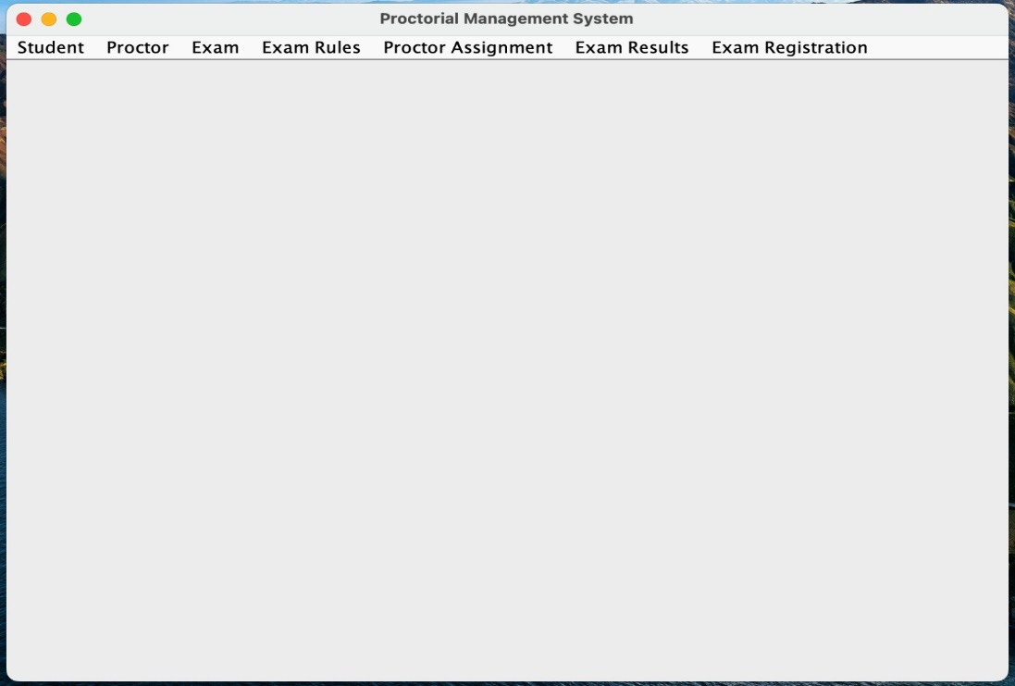

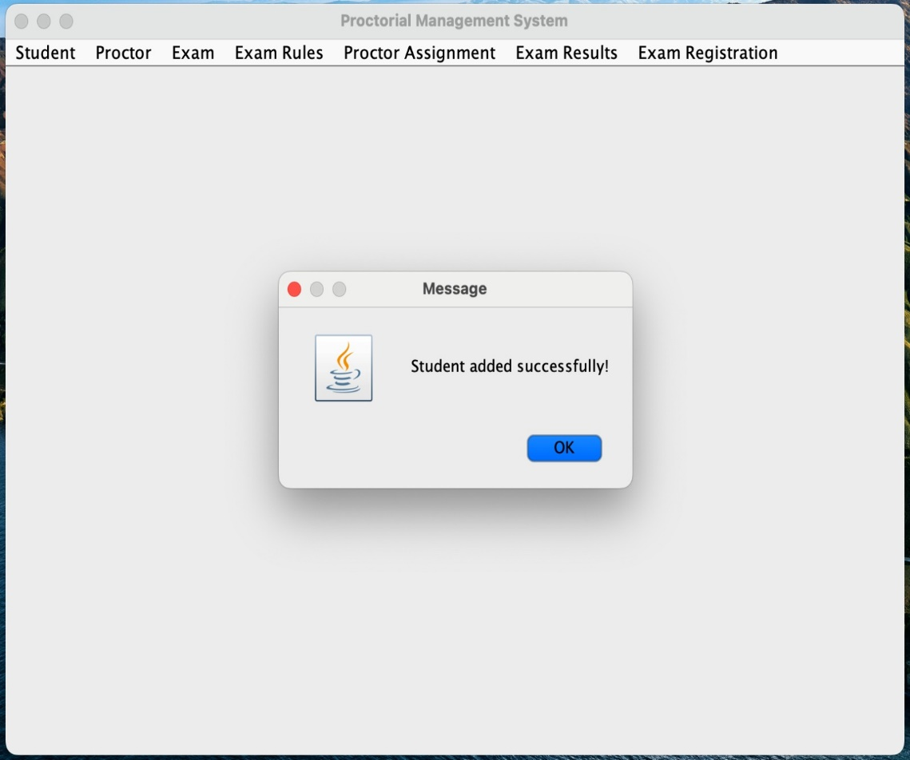

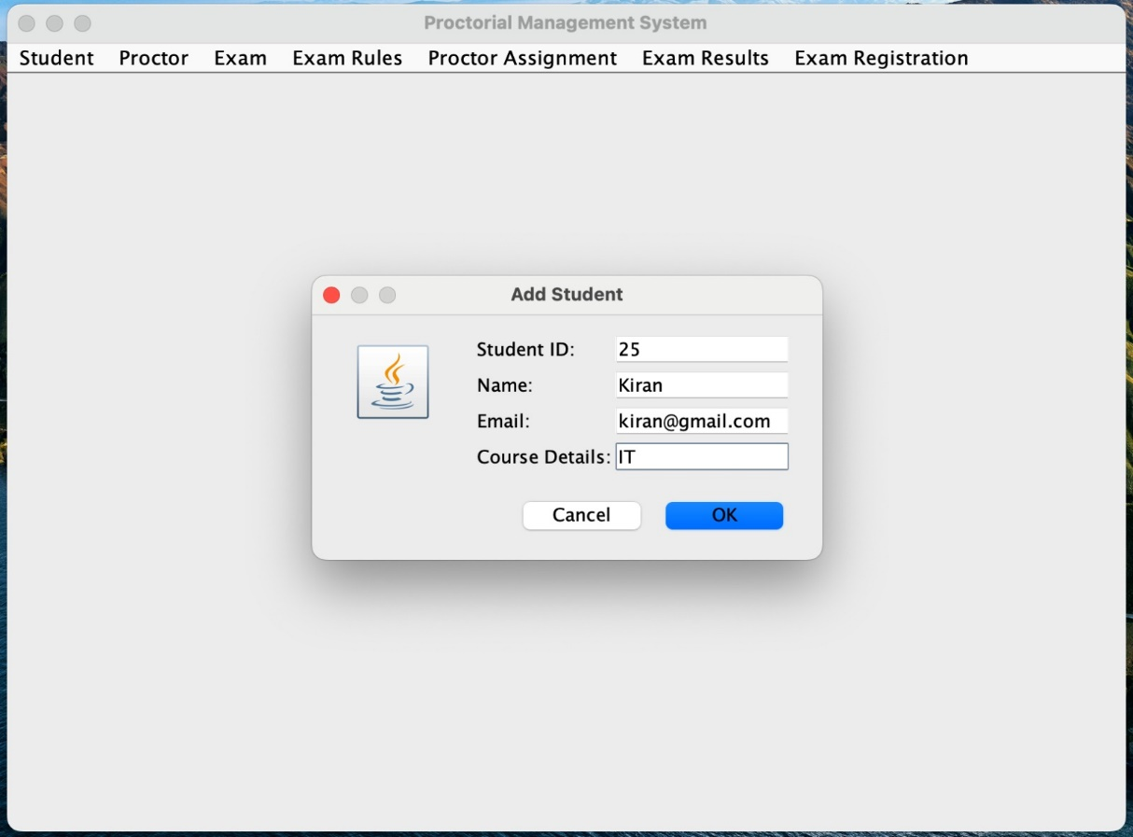

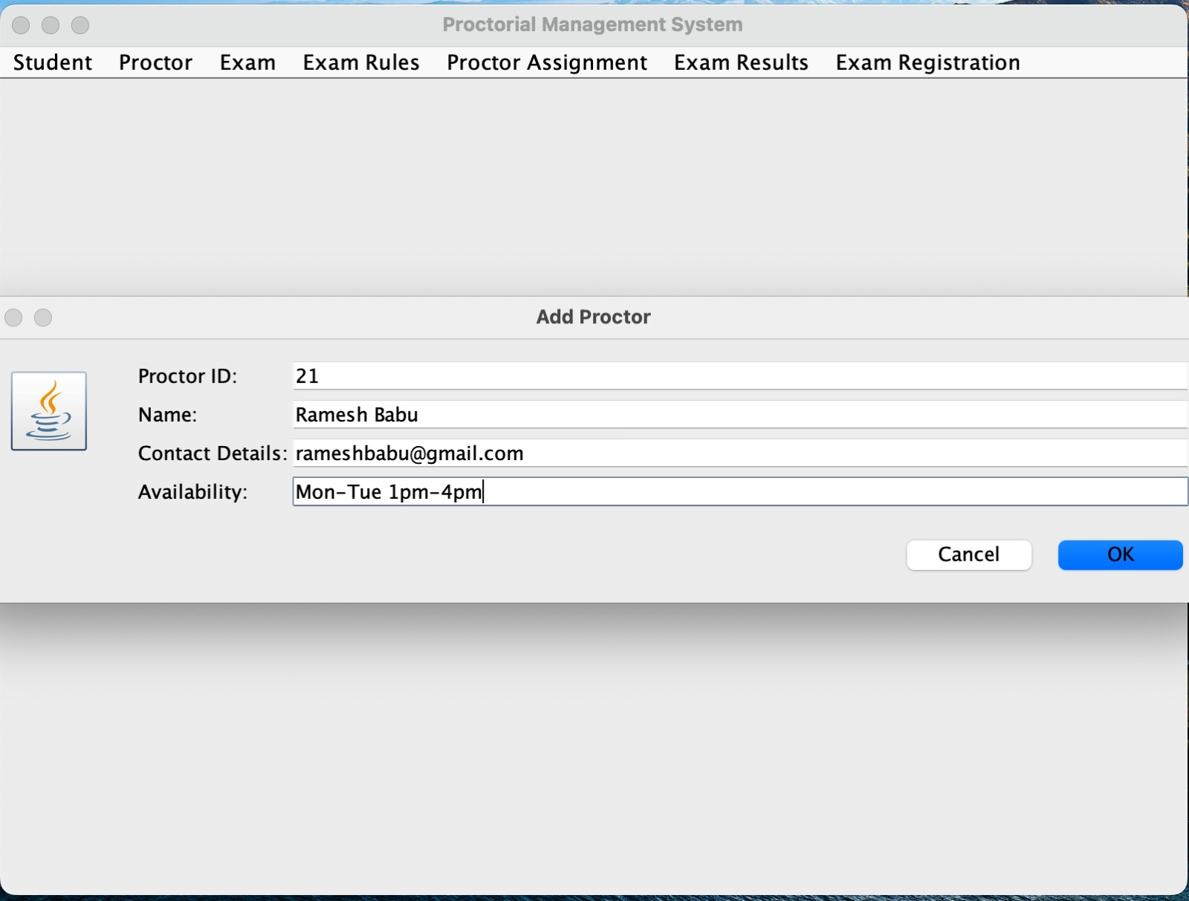

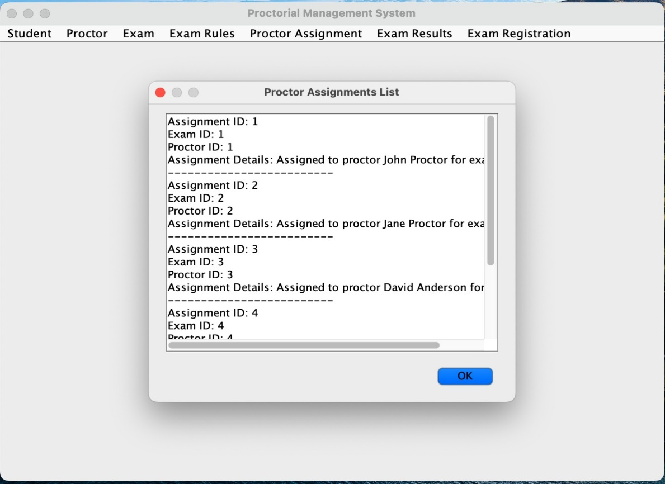

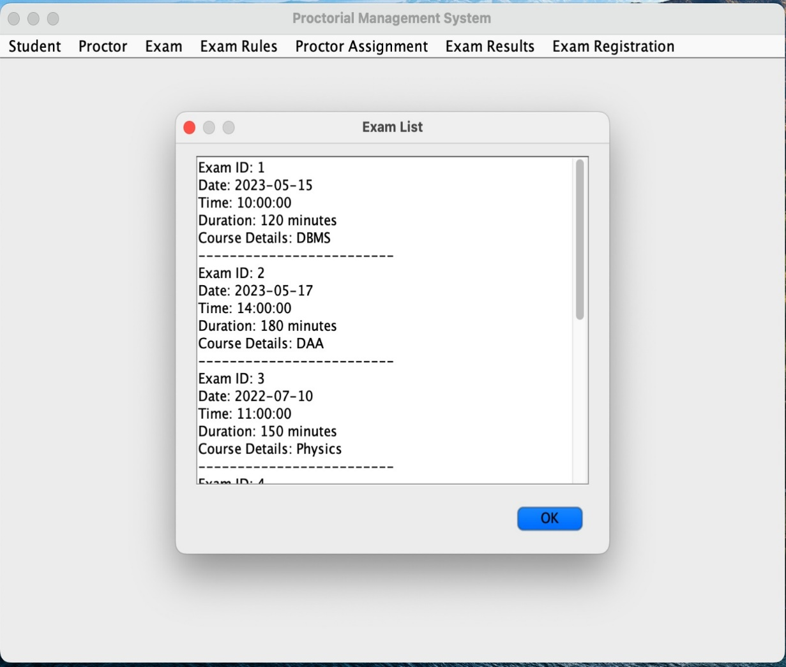

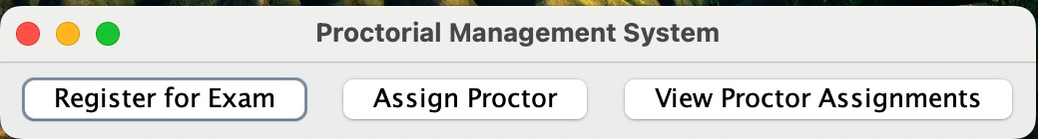

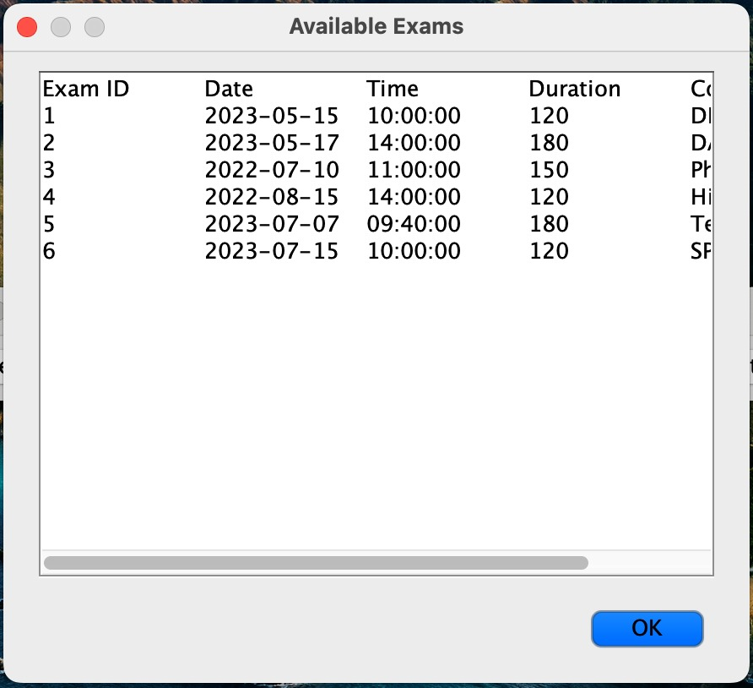

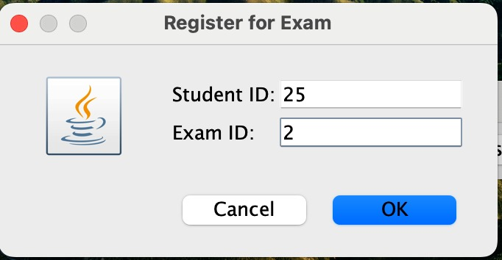

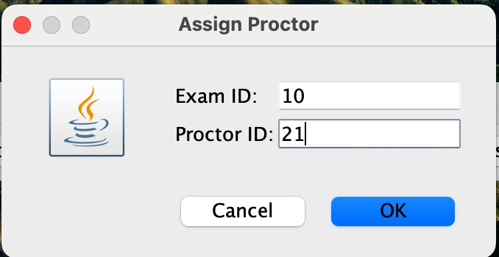

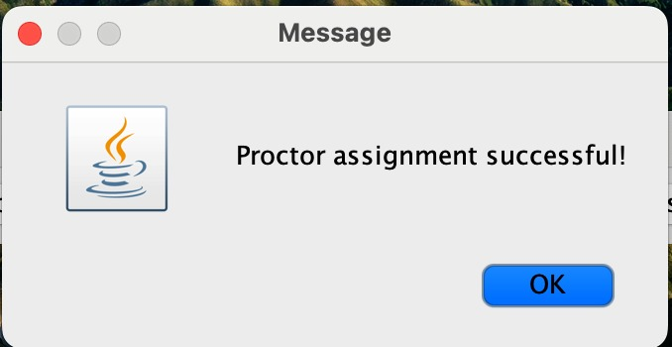

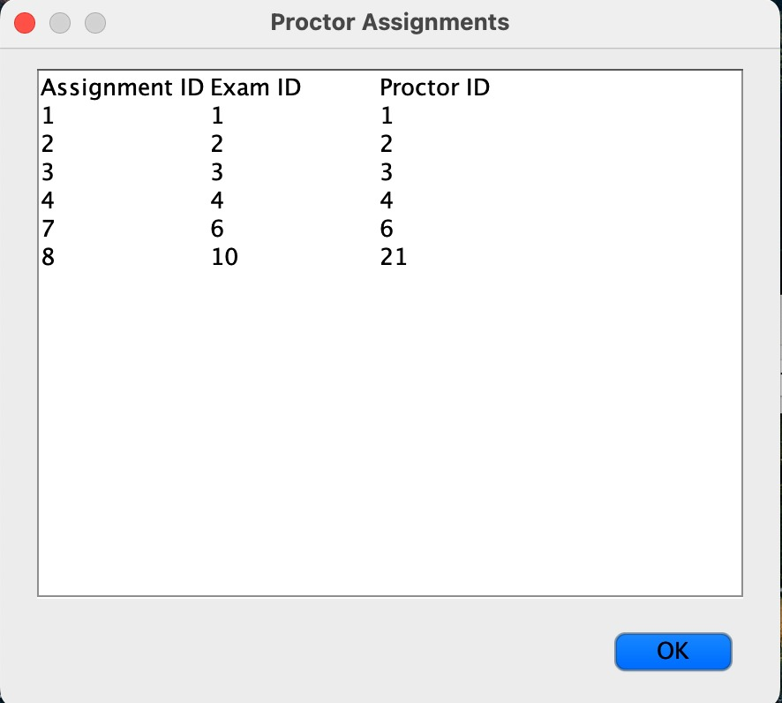

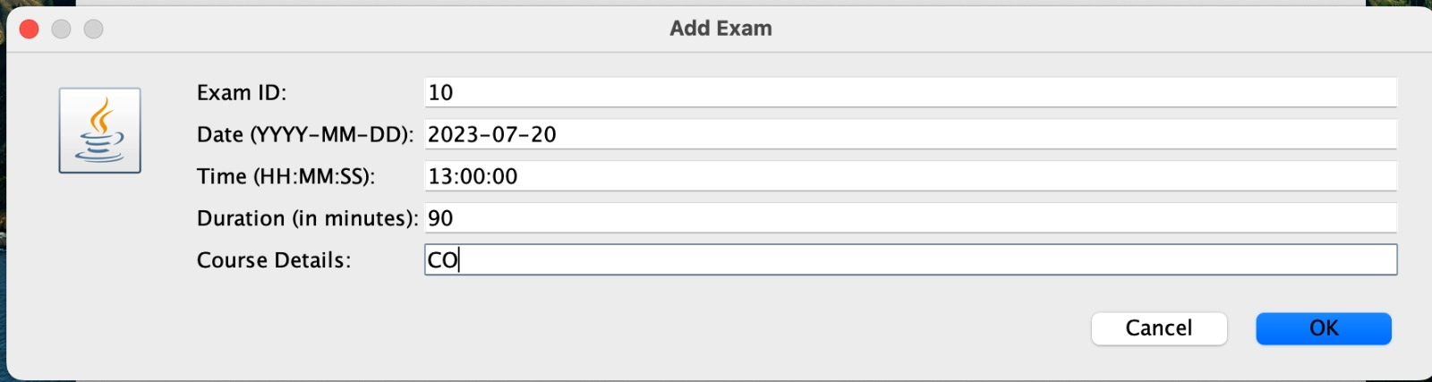

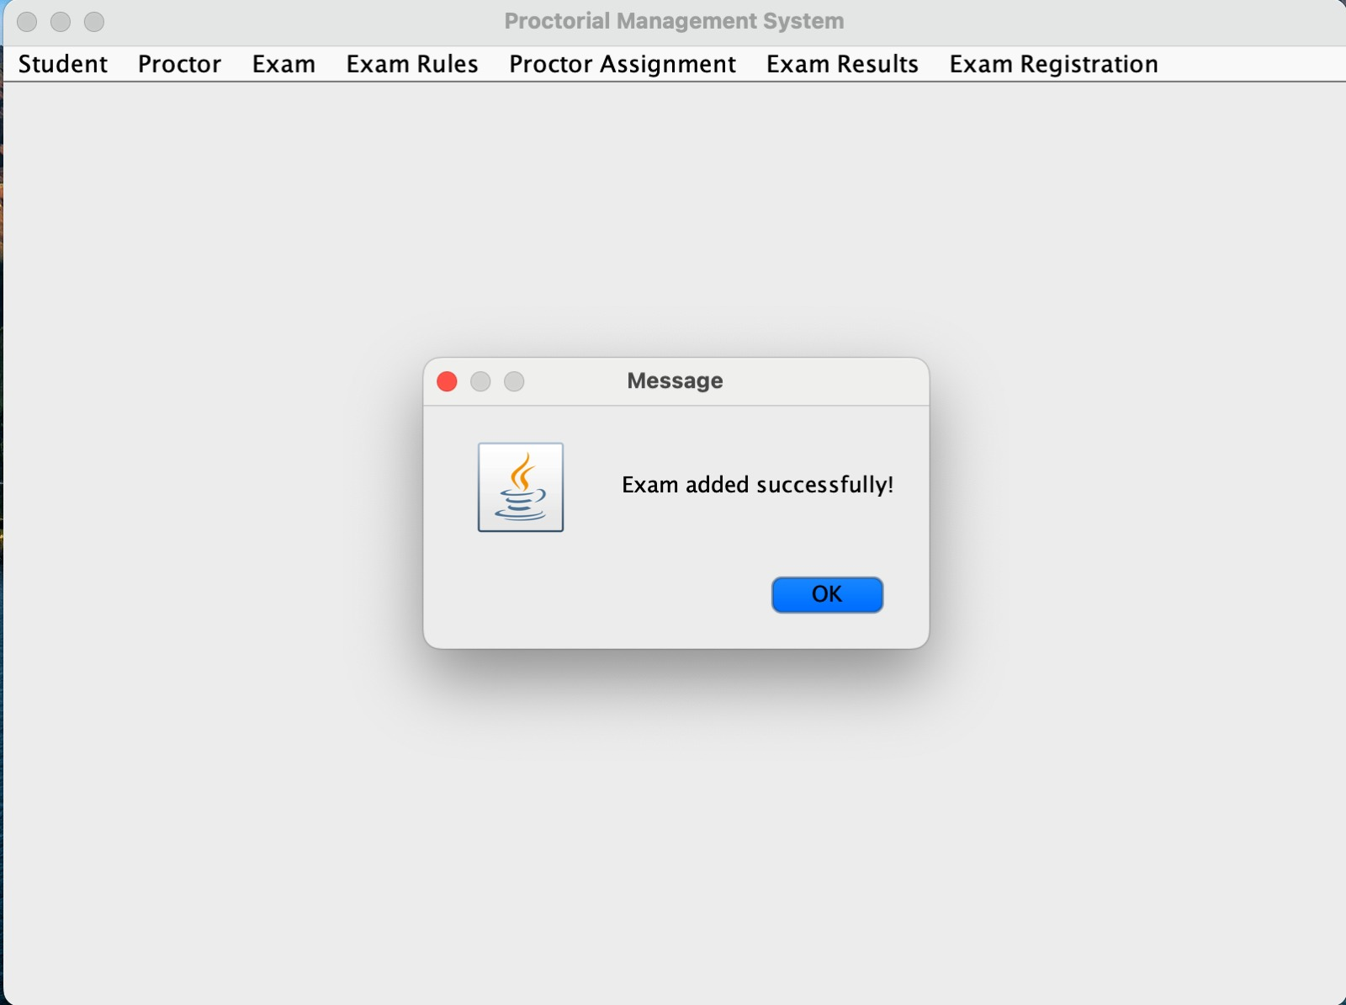

**REFERENCES:**

[**https://github.com/jyoshnapasham/Proctorial_Management_System.git**](https://github.com/jyoshnapasham/Proctorial_Management_System.git)

[**https://livesql.oracle.com/apex/f?p=590:1000**](https://livesql.oracle.com/apex/f?p=590:1000)